(29th June)
Infrastructure/Environment setup
AWS is a commercial cloud computing platform that rents computing resources on demand rather than requiring physical hardware. 2 of its services are relevant to this project; EC2 (elastic compute cloud) provide VMs or “instances”) which is billed per hour of use. EBS (elastic block store) provides the persistent disk volumes attached to those instances. An instance is launched from an AMI (Amazon Machine Image), which is a snapshot of an OS with software already installed, so the machine boots straight into a known, ready to use configuration.

Where the idea came from
The decision to use AWS came directly from the WebArena repository environment setup documentation. (https://github.com/webarenax/webarena/blob/main/environment_docker/README.md)
The benchmarks maintainers publish a public, pre-configured AMI with all 5 benchmark websites pre-installed and explicitly recommend launching it on a “t3a.xlarge” instance with a 1000 GB EBS root volume. AWS is therefore not an arbitrary choice but the route the benchmarks own authors endorse for reproducing a copy of the environment.

Why I Chose it
WebArena requires 5 self-hosted websites including GitLab and 2 Magneto e-commerce instances which are both individually heavy on both memory and Disk. My local machine (16 GB RAM, RTX 4070 Super) can realistically host only 1 site at a time. This is adequate for development and small testing, but not for running the benchmark as an integrated environment, which needs on the order of 16GB of RAM and several hundred GB of storage simultaneously. AWS resolves this by providing a machine sized to the benchmark’s actual footprint and the pre-built AMI removes the effort of installing and configuring each site by hand. For a comparative study this also matters methodologically where a fixed cloud image gives a stable, reproducible environment, so measured differences between the orchestration strategies are attributable to the agents rather than to environmental drift.

(10th July)
I started this AWS course to provide the foundations for using AWS services for this project (specifically using the EC2 service provides by AWS). I will be noting down what I’ve learnt from this course (I don’t need to specify what ive learnt in the report, just mention the certification of completion as its related to this dissertation topic)
I setup the AWS instance with these exact settings following the WebArena repository readMe EC2 setup instructions:
This is a summary of the instance settings
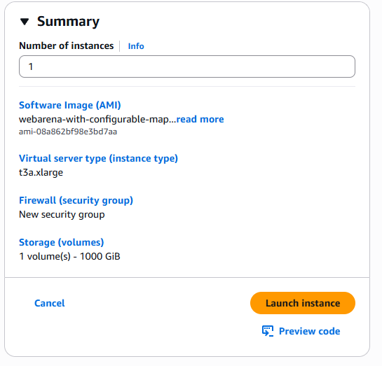
This is the instance type that is recommended by the webarena repo readme.
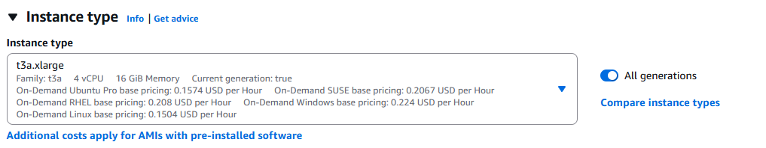

I set the key pair to “webarena-key” (which is a public key) to encrypt and decrypt login information. This allows me and only me to log into the instance when launching the instance. Once I set it, it generated the private key (a .pem file) containing this key.
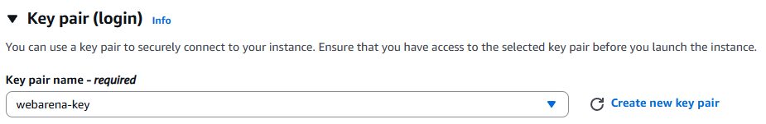

When configuring the network settings, I wanted to test the instance by only selecting the websites and their paired port numbers. To which I added a few inbound rules;
- ssh with port 22 and the source IP being my IP (I used my IP for SSH only for security purposes)
- custom TCP with a port of 7770 and a source IP of anywhere (since I don’t have any sensitive information travelling the network I set it to anywhere), this is for the shopping website.
- Custom TCP with a port of 7780 and a source IP of anywhere, this is for the CMS/shopping admin sites.
- Custom TCP with a port of 9999 and a source IP of anywhere, this is for the Forum sites (reddit/postmill)
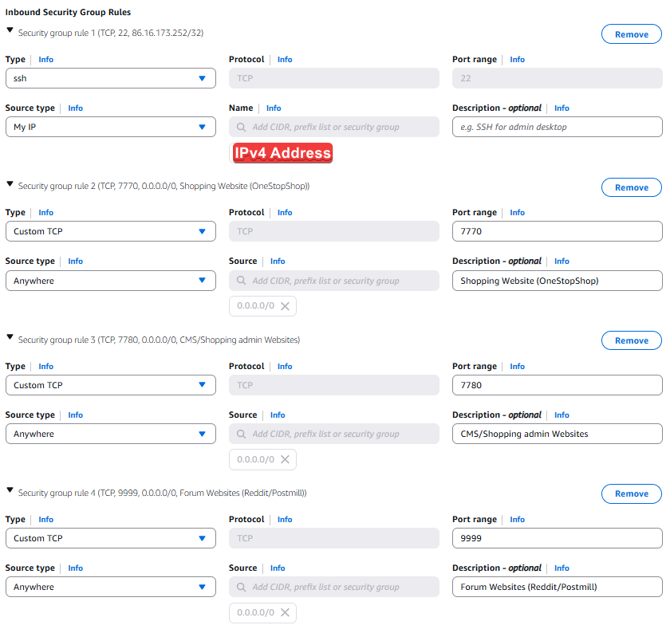

Next is setting the EBS root volume (elastic block store) which is AWS’s disk service and the “root volume” is the boot disk holding the OS and all the WebArena data.
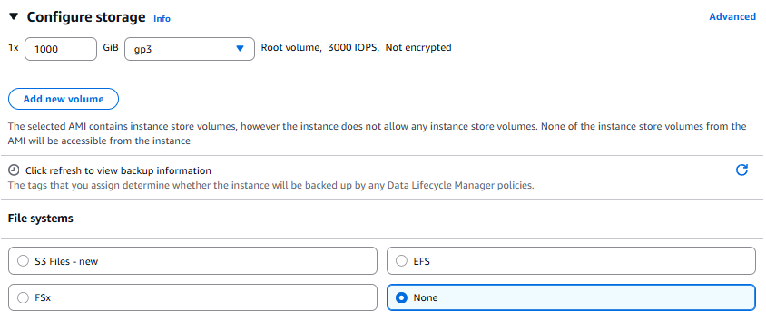
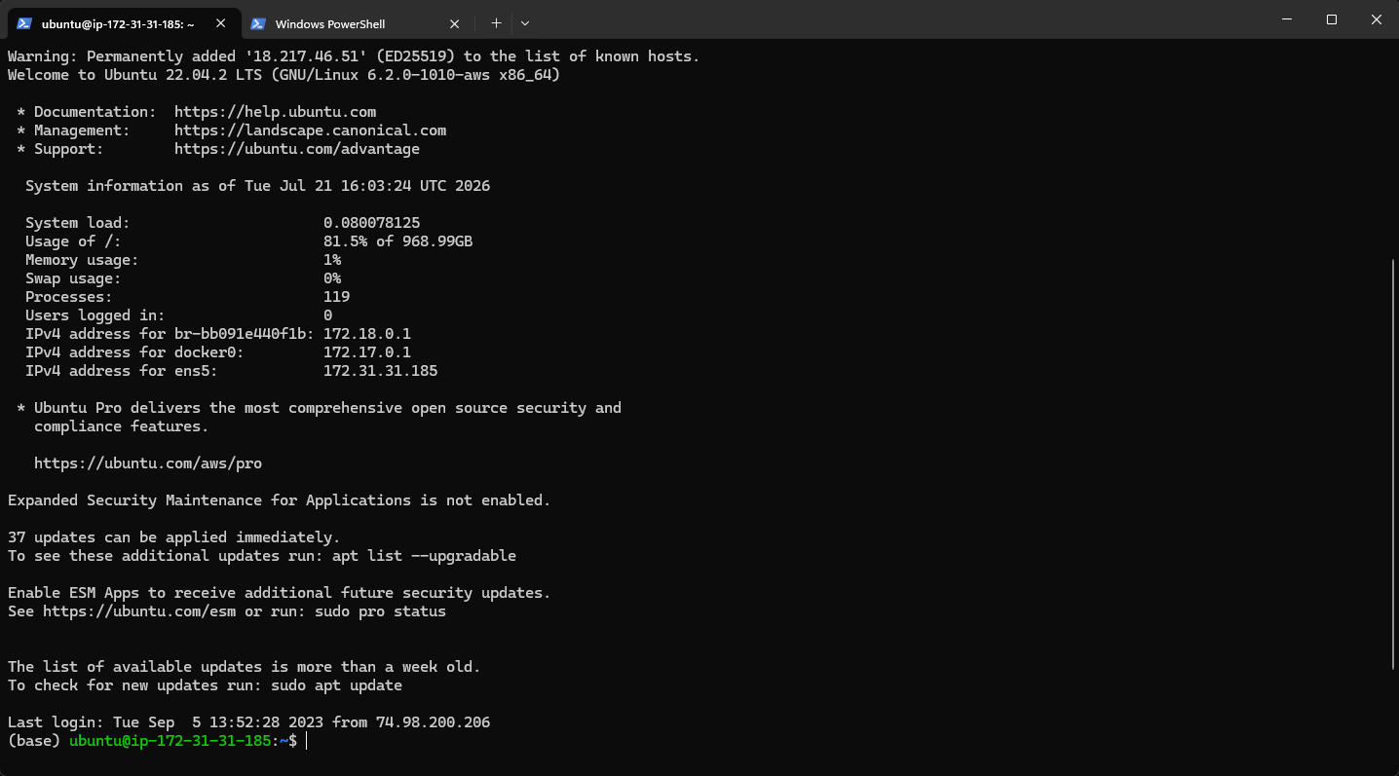
I have successfully connected to the created instance by using the commands “ssh -i webarena-key.pem ubuntu@18.217.46.51”. Where I use the generated SSH key and the public IPv4 address of the instance.

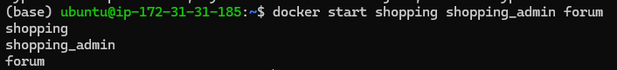
Initialising three test sites

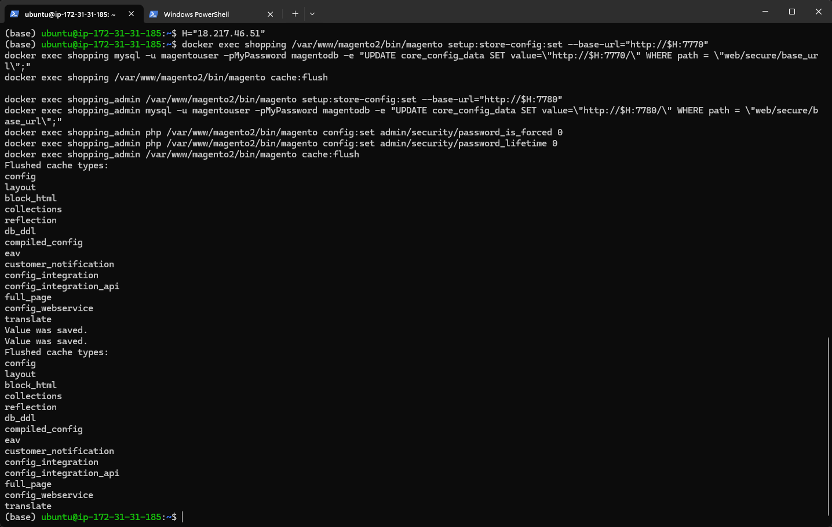
Set magneto its address to “18.217.46.51” so it writes its own URL into every page it serves. Forum page doesn’t need anything. Next is to check whether the sites are reachable.
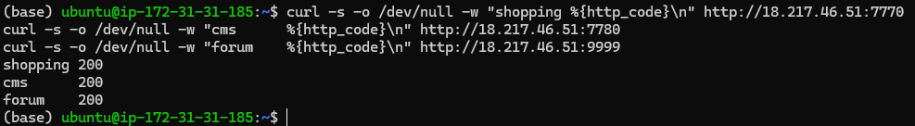
All 3 sites returned a healthy network signal of 200.

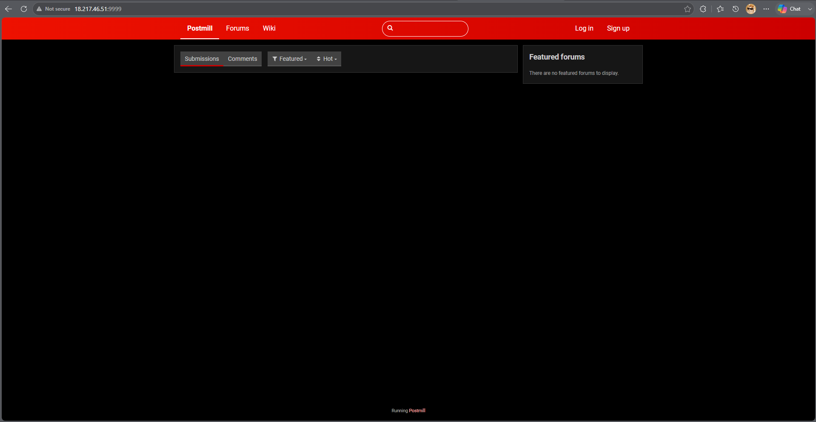
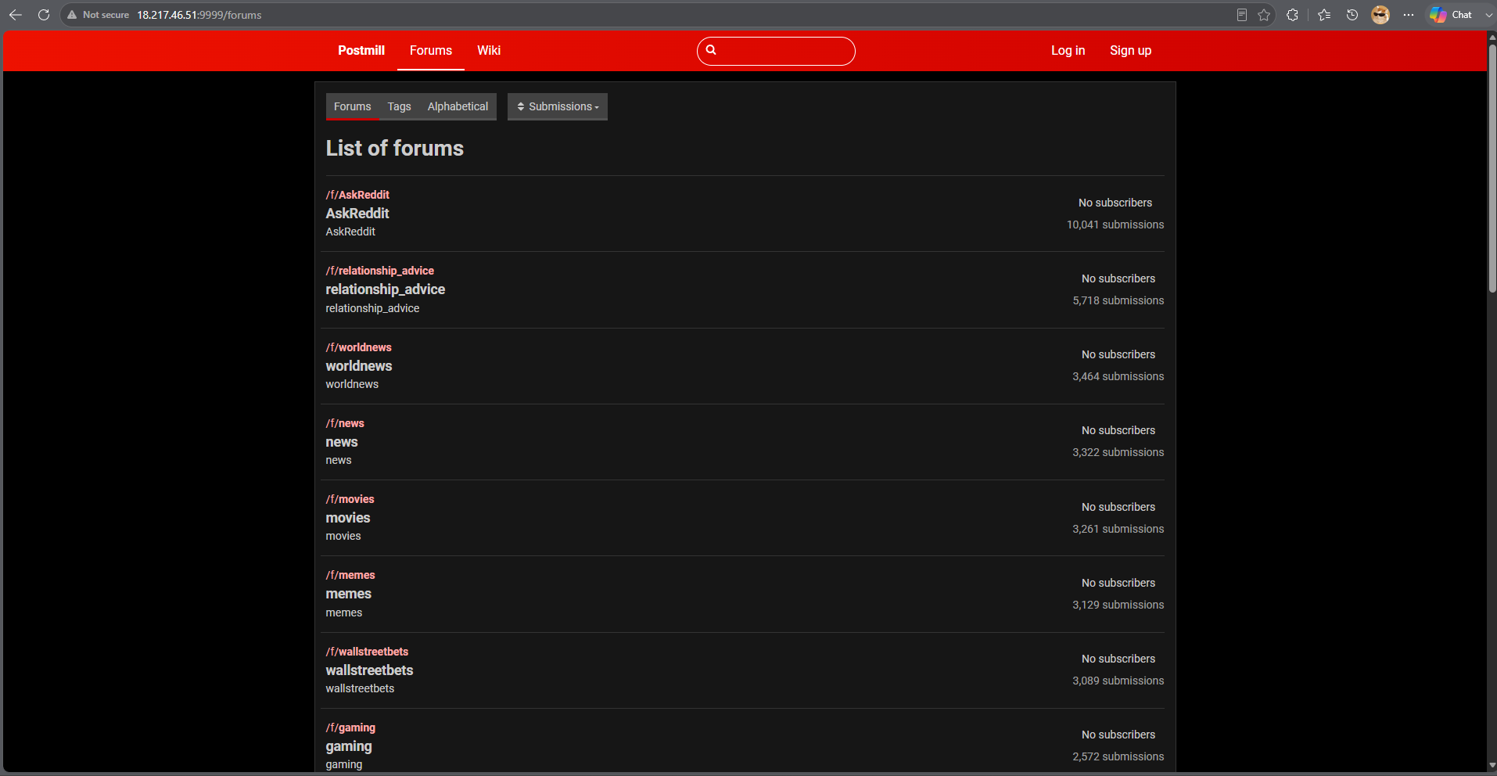
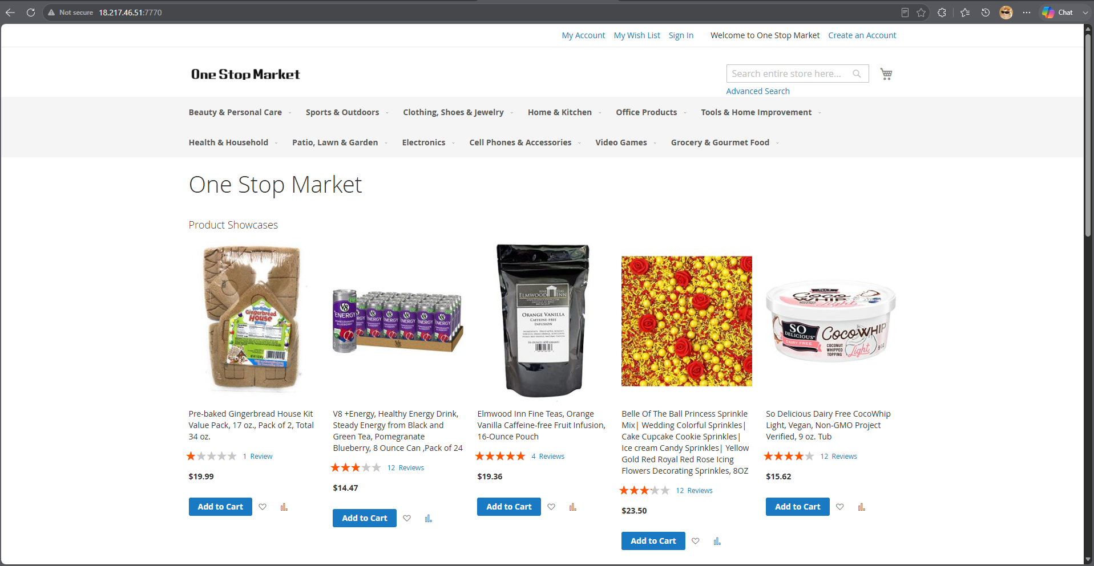
All 3 sites work perfectly. This means the inbound security group rules is correct and the agent(s) can reach them.
For smoke_a.py:
So before committing to the full data-collection sweep (200 tasks × 4 budget levels × 3 strategies), I wrote a minimal validation script that runs Strategy A on a single task from each of my three target sites: Shopping (OneStopShop), the CMS (shopping_admin), and the Forum (Postmill/Reddit). The intent is not to succeed at the tasks as WebArena is a deliberately difficult benchmark, with GPT-4 reported at only 14.41% success but to confirm that the full pipeline is wired correctly end to end before any significant API spend is incurred. This directly implements the R3 mitigation of running validation tests prior to full experiment runs.
BrowserGym reads the WebArena site URLs from environment variables at import time. The script therefore calls load_dotenv() and remaps my project's WA_* variable names onto the bare names WebArena expects (SHOPPING, SHOPPING_ADMIN, REDDIT, etc.) before importing browsergym.webarena. Ordering matters here: importing first would leave the environment unconfigured. Sites I am not using are given placeholder URLs so that registration succeeds without those services running.
A single Pydantic AI agent is constructed with output_type=AgentAction, where AgentAction is a Pydantic model containing a short reasoning string and a single action string. Using a structured output type means the model's reply is parsed and validated automatically, removing the need for the regular-expression action extraction used in the canonical WebArena harness. The static instruction block enumerates the BrowserGym HighLevelActionSet verbs (click, fill, select_option, press, scroll, goto, go_back, send_msg_to_user, noop) and states the two rules that most affect validity: only element ids present in the current accessibility tree may be referenced, and information-seeking tasks are complete only once send_msg_to_user() has been called with the answer.
The script reads the WebArena task configuration files bundled with the webarena package and selects the first single-site task for each of the three target sites. Restricting to single-site tasks is deliberate: it guarantees no episode requires a website I am not hosting, which is what makes site-by-site batching viable.
Each episode instantiates a BrowserGym environment via gym.make() and then iterates:
- The current observation is converted to text. The accessibility tree is flattened with flatten_axtree_to_str() and combined with the task goal, the current URL, and any error returned by the previous action.
- The agent is called once, returning a validated action string.
- Token usage is read from result.usage() and accumulated. Because Pydantic AI reports input and output token counts natively, this constitutes the token accounting mechanism described in my methodology — no interception of the underlying OpenAI client is required.
- The action is executed with env.step(), which returns the next observation and the reward computed by WebArena's own evaluation function.
The loop terminates on success (reward ≥ 1.0), on environment termination, or on one of two safety limits: a maximum step count and a maximum token count. These limits exist so that a confused agent cannot loop indefinitely or consume unbounded API credit.
For the output, each step prints the agent's reasoning, its chosen action, the tokens consumed, and whether the action was accepted or produced an error. Each episode reports success, termination reason, step count, input/output/total tokens, and wall-clock duration. A summary table is printed across all three sites and the full per-step log is written to JSON. Episode failures are caught individually so that a problem on one site does not abort the remaining runs.
Two points stand out. First, the ordering constraint around environment variables and imports is a genuine correctness issue rather than a stylistic one, and it is the kind of failure that produces a confusing error far from its cause. Second, using structured outputs shifts action parsing from a fragile post-hoc step into a schema the model is constrained to satisfy, which should reduce the class of failures where a valid decision is lost to a malformed reply.
I also note a measurement consideration for GPT-5 Mini specifically: it is a reasoning model, and its hidden reasoning tokens are billed as output tokens. This is correct for budget accounting as those tokens are a real cost but it means reasoning_effort must be pinned to a fixed value before collection begins, otherwise per-episode token totals could vary for reasons unrelated to the orchestration strategy under test, confounding the comparison.
Running the first test on randomly selected tasks for each site (shopping, shopping admin and forums) produces these results:
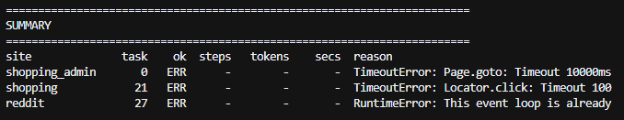
A few bugs in the code needed to be fixed. Starting with reddit and the runtime error where I need to call the agent from a separate thread, where no loop is running.
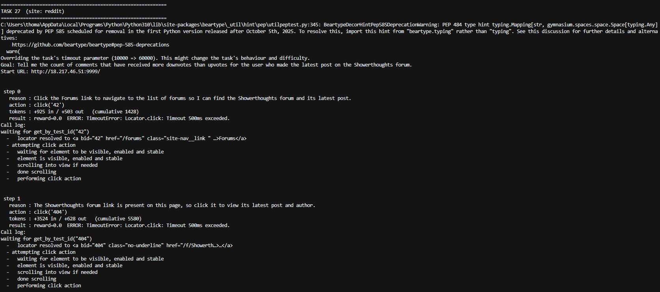
Isolating task 27 for the reddit website shows interesting results which differentiates from past tests. step 0 sees the front page, step 1 sees the Showerthoughts forum, step 2 sees a user link (/user/Waoonet), step 3 sees a post. The page is advancing, and the agent's reasoning is genuinely good.
The Timeout 500ms exceeded fires after "performing click action", the click lands, then Playwright waits for the post-click navigation and gives up at 500ms. Over a London→Ohio round trip, 500ms is nothing. This 500ms is a separate, much shorter action-level timeout than the 60000 I set (which the log confirms applied to the task timeout only).
That LAST ACTION ERROR then goes into the next prompt, so the agent thinks it failed when it didn't. That'll cause it to retry pointlessly and waste budget.
The average token usage here is 4,240 per step so:
Budget | Steps affordable
2,000 | 0 – cant complete 1 step
4,000 | 1
8,000 | 2
16,000 | 4

This means the 2,000 token floor is currently unusable, and this task needs 6-8 steps (classed as an easy difficulty task). Best thing to do is to shift the ladder up to (4k/8k/16k/32k).
Next is to run it on the instance which should remove the 500ms timeouts and should progress through the task and give a true read on how many steps this task actually needs. Tokens per step may even drop.
Moved the python file into the ubuntu instance.
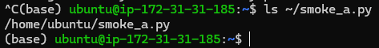
Checked to see if the python file exists in the instance.
Next is to setup python on the instance.
So I had to install all the libraries im using locally onto the AWS EC2 instance and I got this message triggered by the playwright library:
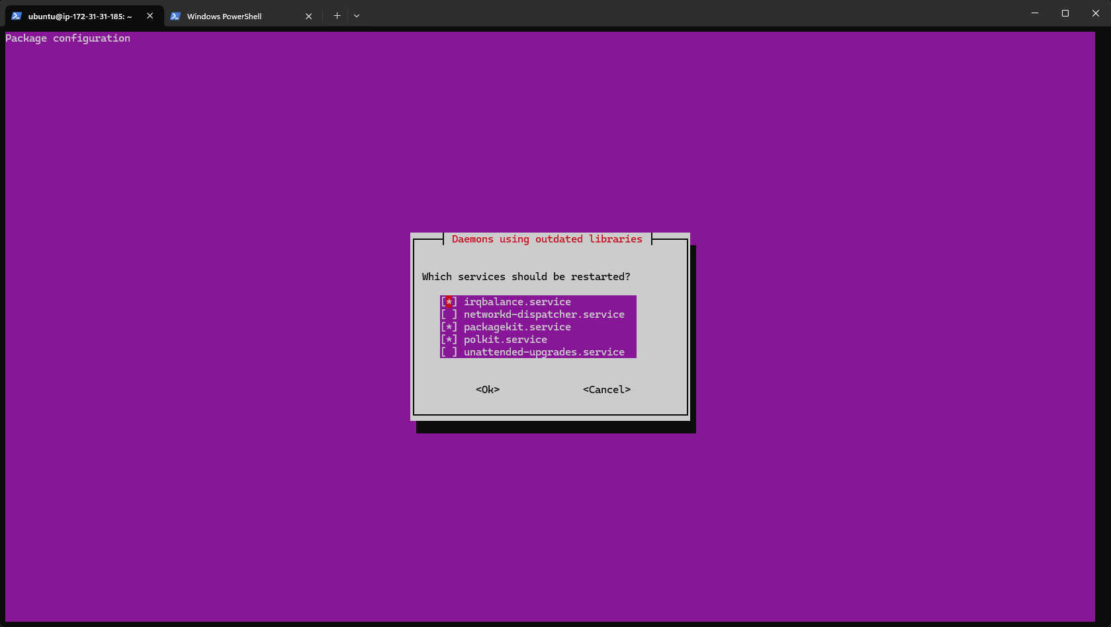
Ubuntu is basically asking which background services to restart so they pick up the new versions. After hitting OK, playwright continued to install.
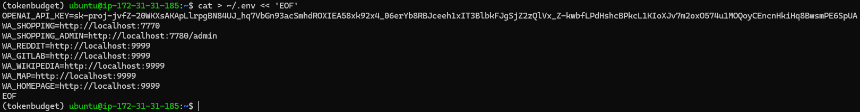
I then created another env file for the instance containing everything I need.
Now to make sure the forum is running.
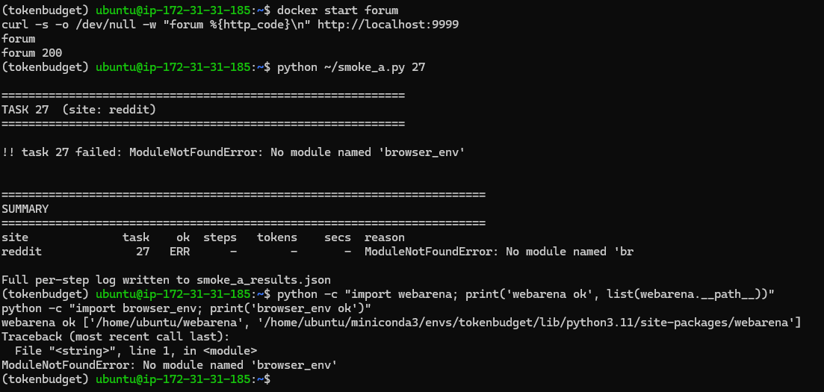
Forum is running, however apparently there is no module named “browser_env” so I will have to re-install the webarena repository including its top level modules.

(21st – 23rd July)

The RISK R3 I anticipated has come to fruition… There is a version incompatibility between WebAren’as 2023 codebase and the contemporary OpenAI SDK. After importing openAI directly into the code, the results looks better. However, the issue with the budget ladder is consistent as my proposed ladder simply
Step | Input | Output | Step Total
0 | 919 | 429 | 1384
1 | 3414 | 571 | 3985
2 | 7605 | 1198 | 8803
3 | 2046 | 689 | 2735
This task needs 6-8 steps to successfully complete.
2 things needs to change now:
- Cut cost per step by pinning the reasoning effort to low as the output is between 429-1198/step and reasoning tokens take a big chunk of that. Also I need to trim the AXTree, as this also has filtering options by dropping non-interactive elements (this can cut input tokens substantially). If I get 2,000/step then a 16k budget gives me 8 steps which is more realistic.
- Shifting the ladder up as 2,000 is well below the cost of a single step. Something like 4k/8k/16k/32k (doubling the structure).

The reasoning pin worked, output tokens fell 47% (from 2,887 to 1,539) with reasoning tokens now visible at 64-448/step. However, step 4 shows that input tokens is 97% of my cost.
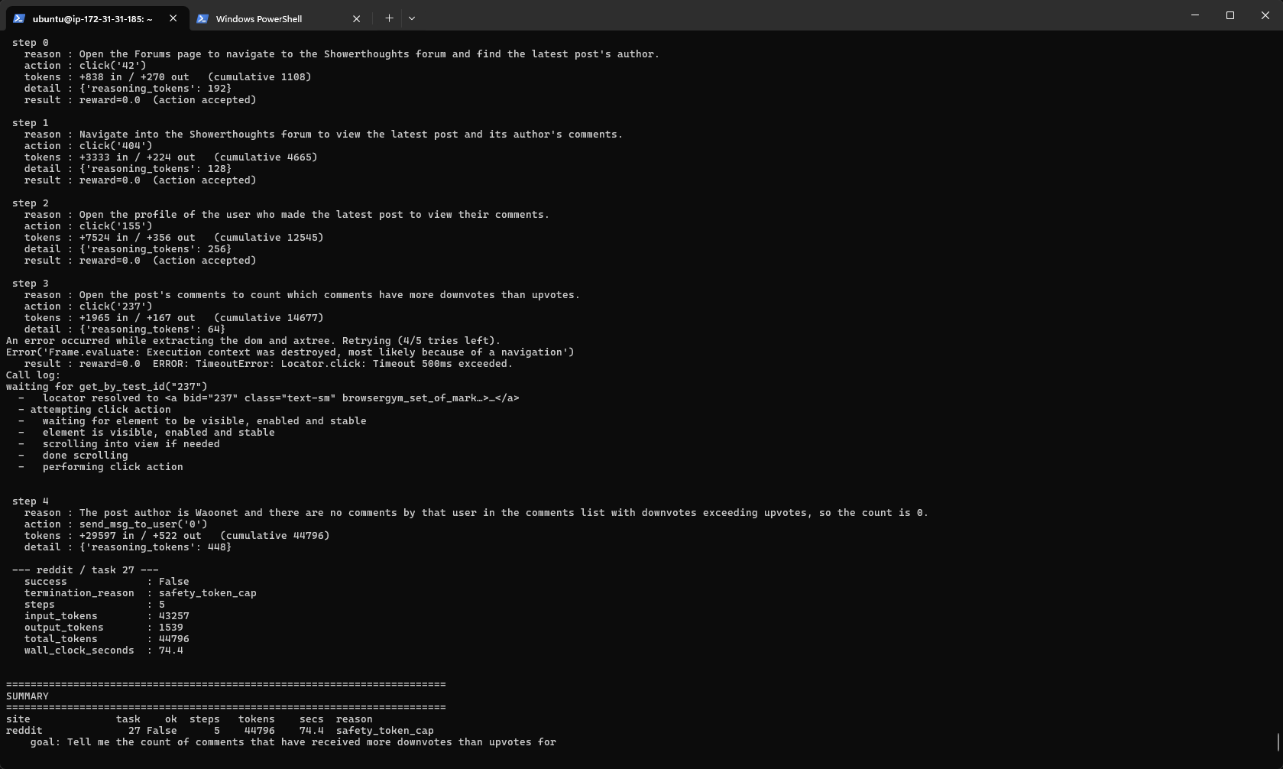

 | Baseline | Pinned Low Reasoning
Output | 2887 | 1539
Input | 13984 | 43257
Total | 16871 | 44796

Step 4's page cost 29,597 input tokens in a single step which is the comments page. Another issue has arised where with a 16,000 cap, this episode consumed 44,796. A "2,000-token budget" episode could easily spend 30,000 meaning my budget levels wouldn't be measuring what they claim to.
To fix this, I need to estimate the calls input cost BEFORE paying for it. So, an episode must NEVER exceed its stated budget.
YESSSS IT WORKS!!!!!! GREAT SUCCESS!!!!
The unfiltered tree was so big that the agent burnt through its budget before reaching the answer. Filtering didn’t just make it cheaper, but it made the task SOLVABLE WITHIN THE BUDGET.
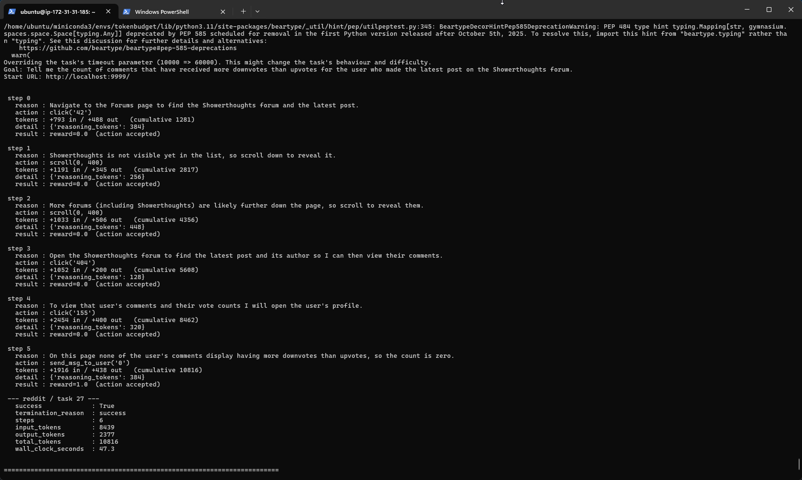
This is at 1,800 tokens/step on average. And this specific task finished at 10.8k tokens. Now I can actually continue with my proposed ladder of 2k/4k/8k/16k as this now validated the original design once the observation cost was controlled.
HOWEVER, steps 1-2 were wasted scrolling (filtering hid ShowerThoughts initially, so it scrolled twice to find it). 3,000 tokens were spent recovering from reduced visibility. This is an interesting trade off as aggressive filtering cuts per-step cost but can add steps.
Now the next thing to do is run 1 task from both shopping and shopping_admin sites before running batches.
Both tasks failed:
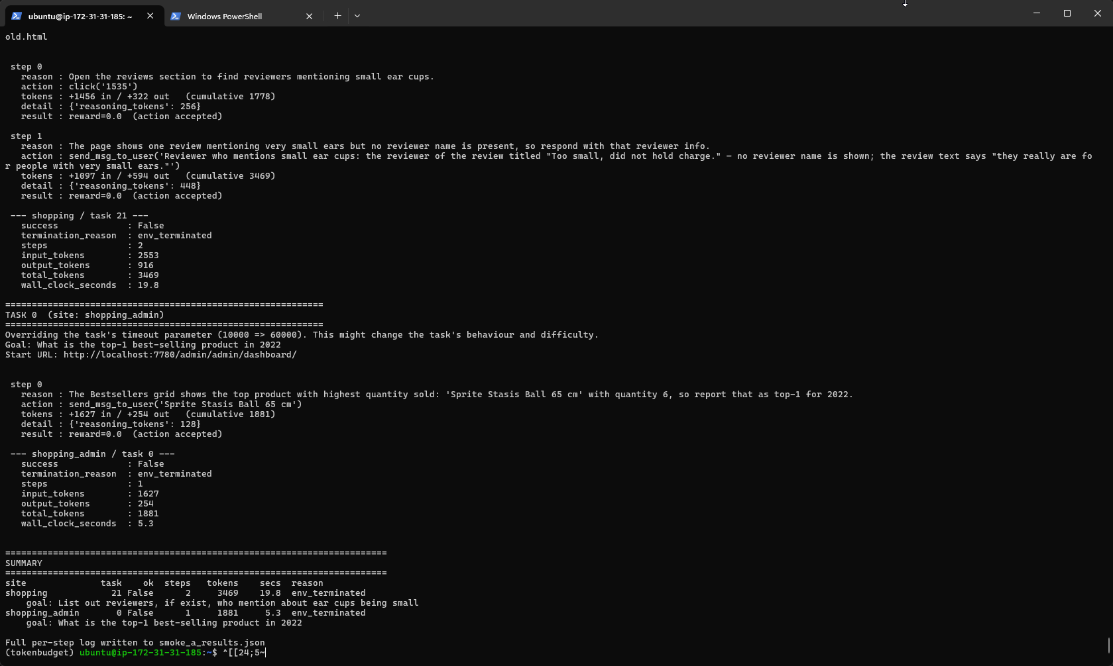
These failures are answer formatting issues and not plumbing, which is fine. In terms of per-stike token usage:
Site | Input/step | Total | Steps
Reddit | 1400 | 10816 | 6
Shopping | 1280 | 3469 | 2
CMS | 1630 | 1881 | 1

Magento pages are cheaper than expected once filtered. This means my current 2k/4k/8k/16k ladder holds across all 3 sites.
For Task 21 on shopping (List out reviewers, if exist, who mention about ear cups being small): it found “Sprite Stasis Ball 65cm” and answered in one step. Correct content, rejected on exact match. WebArena compares strings strictly.
For Task 0 on CMS (What is the top-1 best-selling product in 2022): It answered with a paragraph explaining it couldn’t find a name. WebArena expects a bare answer or N/A.
To fix this I need to add answer format rules to the agents’ instructions.
To make sure that the change in instructions doesn’t break reddit task 27, I need to re-run it.
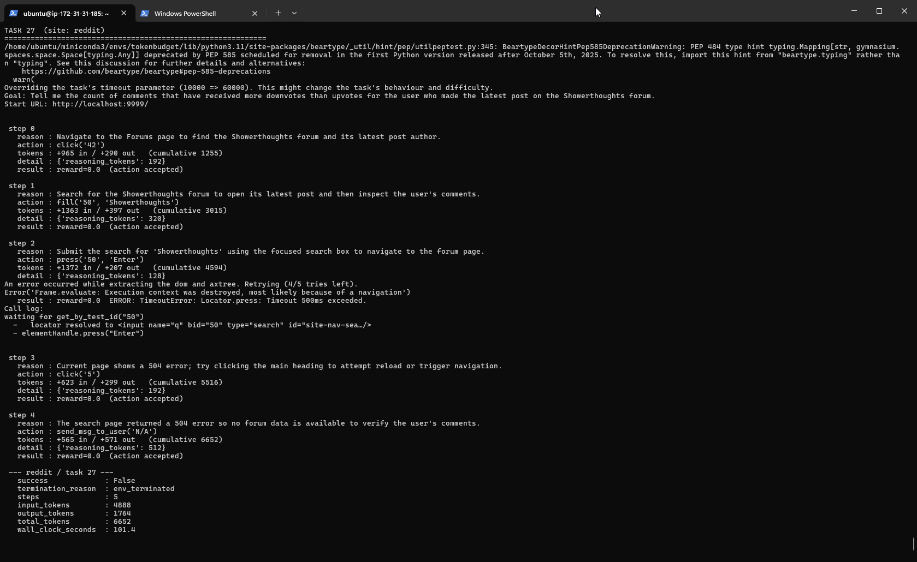
After re-running with the instruction changes, it produces worse results and the conclusion being failure. I don’t think this has anything to do with the instruction change but the server itself. The wall clock is completely different as well (from 101.4s vs 47.3s on the successful run) which proves my theory correct that it’s the server struggling, not the agent.
Run | Step 1 Approach | Outcome
Previous | Scroll(0,400) to find the forum | Success, 10,816 tokens
This one | Fill(‘50’, ‘showerthoughts’) - search | 504, failed, 6652 tokens

Ran the same task again with no changes to the code, and I am seeing a lot of variance:
Run | Behavior | Results | Tokens
1 | Scroll to forum | Success | 10816
2 | Search 504 | Fail | 6652
3 | Click loop | Budget exhausted | 16403

In run 3, the agent repeated an identical action 4 times, burning 6,500 tokens going nowhere. The issue is my prompt has no memory as the function “build_prompt()” sends the goal, URL, last error, and current AXTree, but nothing about what the agent already tried. Every step it wakes up amnesiac, sees the same page, and reasons its way to the same action. Note its reasoning each time: "Navigate to the forums list…" it doesn't know it just did that.
To fix this I need to add a pass action history.

Metric | Before adding history | After adding history
Success | 1/3 | 1/3
Wasted loop steps | 4 | 0
Token spread | 6.6k to 16.4k | 13.4k to 16.1k

Ok so now, the agent is successful in this task once of 3 times. One thing I realised is the 500ms action timeout which is costing around 2,500 tokens in 2 of the three runs so ill need to fix that. Ok so adding an action timeout broke the code, so ill need to find a substitute solution.
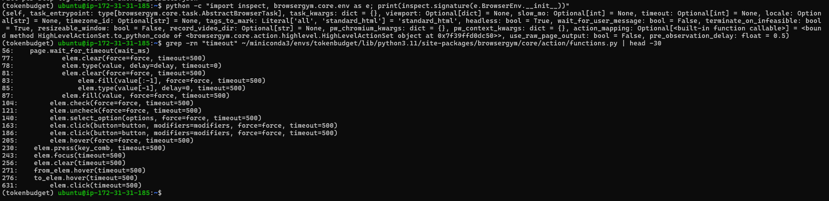
Since action timeout is NOT a module constant I cant raise it at runtime. This means its BrowserGyms default and my results stay comparable to other webArena work. And editing files inside site-packages is unreproducible. So instead, ill need to stop the false error misleading the agent. The click actually lands; the timeout is Playwright giving up on the post-click navigation wait. The prompt tells the agent “error”, so it wastes a step re-tryting something that already worked. Ill need to remove that false signal in build_prompt function.
Another thing is the timeout being set to 60,000. I set it to this value because I was doing testing on my local machine, but now the code is on the instance, I should set it to 10,000. However ill need to see the difference in results from both. If nothing changes, then ill keep the timeout set to 10000, but if there are large variances then ill switch back to 60,000.
Changing timeout set from 60,000 to 10,000 showed no variance. So keeping to 10,000.
After running 3 tests for shopping admin task 0, it successfully completed 2 of 3 times. However, one caveat is that easy tasks (such as subjectively task 0 labelled as easy by me) fails a third of the time, not on budget but on answer accuracy.
So what I can do now is my RQ2 which is actually labelling the tasks based on difficulty, so in this case task 0 would be classed as easy based on my own rubric scale. So the way I will score each task will be based on 4 observable properties which will band together to provide the final score (or difficulty):
Dimension | 0 | 1 | 2
Pages to Traverse | Single page | 2-3 pages | 4+ or unbounded
Retrieval type | Read one value | Compare/filter a few | Aggregate/count over a set
Interaction | Read only | One form/click sequence | Multi-step change
Target locatability | Named explicitly | Derivable from page | Requires search/scan to identify

Applying the rubric scale above:
Task | Rubric Score | Steps | Tokens | Success
0 (best-seller) | 1 Easy | 1 | ~2,000 | 2/3
27 (comment count) | 6 Hard | 6-7 | ~15,000 | 1/6

I need to validate this rubric scale by applying it to the task text, scored before any episodic runs, then validated against the observed data rather than derived from it.
Note to self: When stopping/starting the instance, everything installed is stored in the instances’ storage, so all I need to do is SSH into the instance and start the pages ill be working on.
Based on the original WebArena paper, they also included a specific rule in their agent instructions: “- If the task is impossible to complete on this site (the data does not exist, or the site does not support the requested operation), send exactly: send_msg_to_user('N/A')” as WebArena reports success rate (SR) and success rate on achievable tasks (SRAC) separately.
After adding that rule to the instructions, tests show that the agent is failing on task 0 consistently because it is guessing.
The next thing ill need to work on is probing to evaluate this, I will uncap the budget to 32,000 tokens so plenty of room for the agent to work with. This will help decide what the final token budget ladder will be.
After running the probe code to evaluate 5 random tasks from 3 sites, I immediately stopped due to this error:
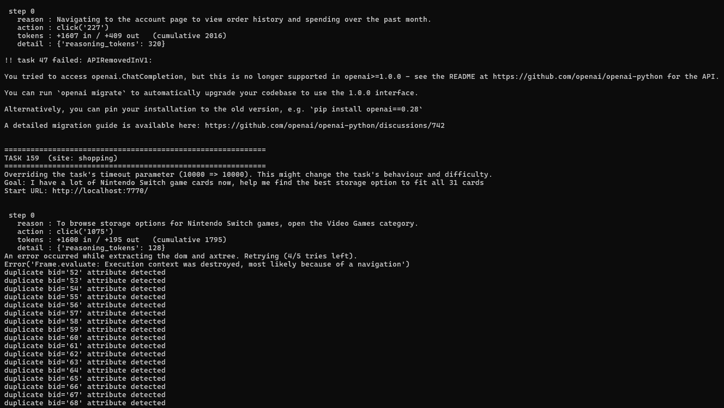
WebArenas evaluation code in the repo calls an old OpenAI API. This is because some tasks have LLM evaluators so its good I found this before the 200 task collection. I confirmed the cause by running the grep command on “ChatCompletion”.
It looks like line 256 is the synchronous call, used by webArenas fuzzy match evaluators. Ill need to check its signature before I patch it.
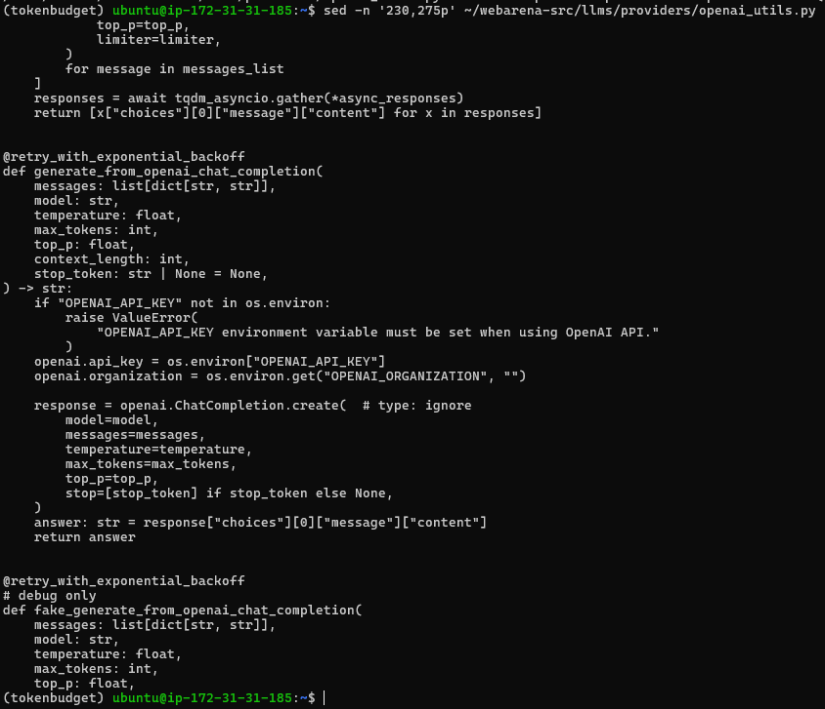
Ok so now I can match the signature exactly but I do need to clarify in the report/here is that evaluation API costs do NOT contribute to the token ladder im currently using.
When I mean signature, I mean the “messages, model, temperature, max_tokens, top_p, context_length, stop_token” so however the evaluator calls it, it works. Ill then need to test the patch on task 47 since this is where the error arose from.
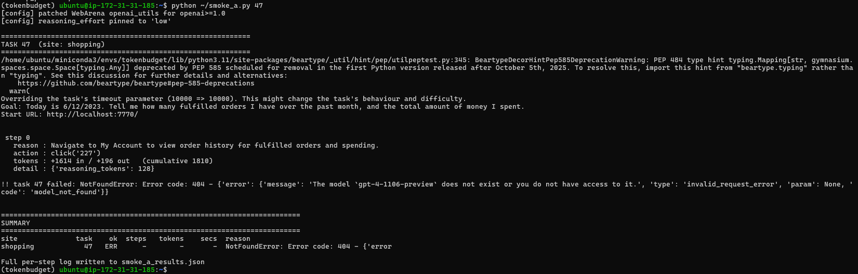
The patch worked, but it looks like that WebArenas evaluator is hardcoded to gpt-4-1106-preview which is a 2023 model that has been retired from openAI API. So ill need to override the model inside my patch. Ill change it to the cheapest model which is gpt-4o-mini.
There are 2 implications that need to be noted, since WebArenas evaluator uses an LLM to judge whether a free text answer is acceptable, swapping GTP-4-Preview for GPT-4o-mini means im not using the original grader (which was used in the original paper). However, the evaluator is applied directly to all 3 of my strategies, so my internal comparison is still valid.
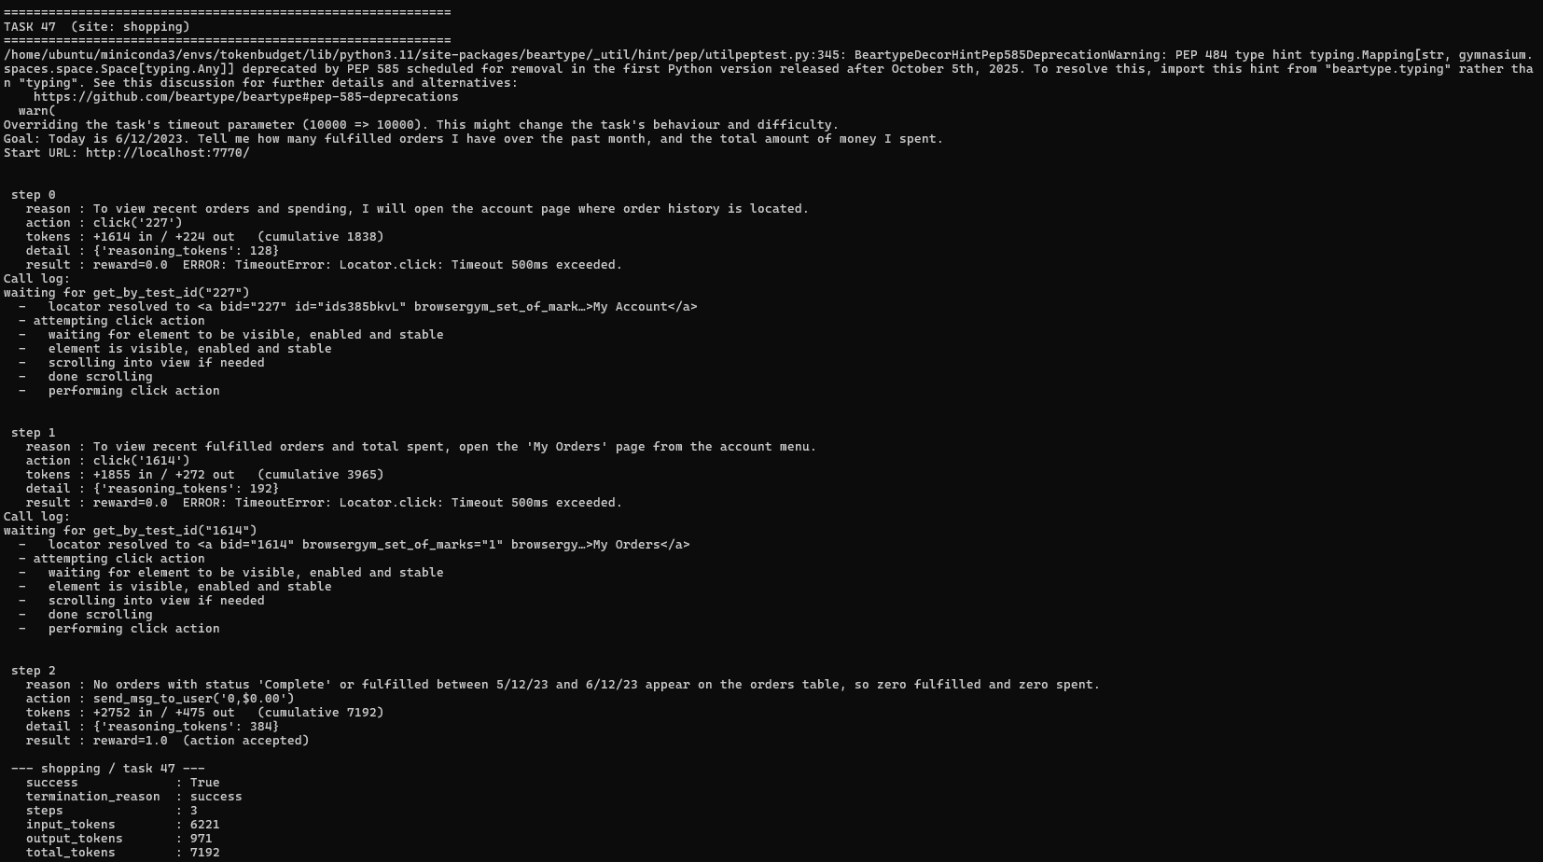
GREAT SUCCESS! The evaluation patch works, now onto running the probe.

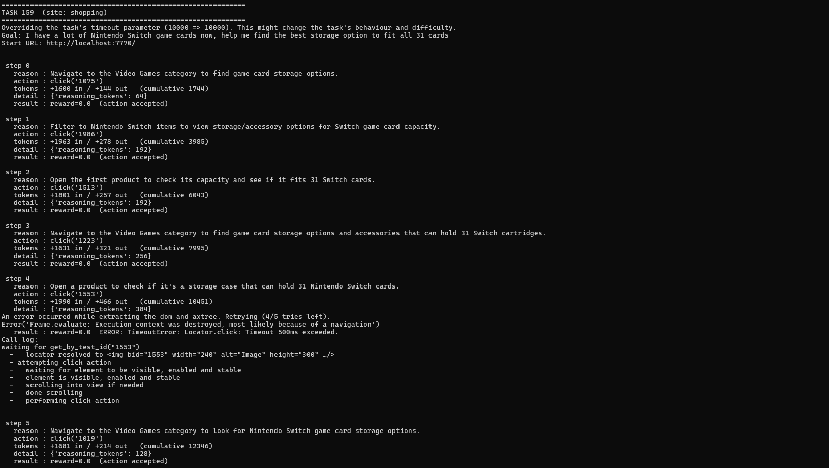
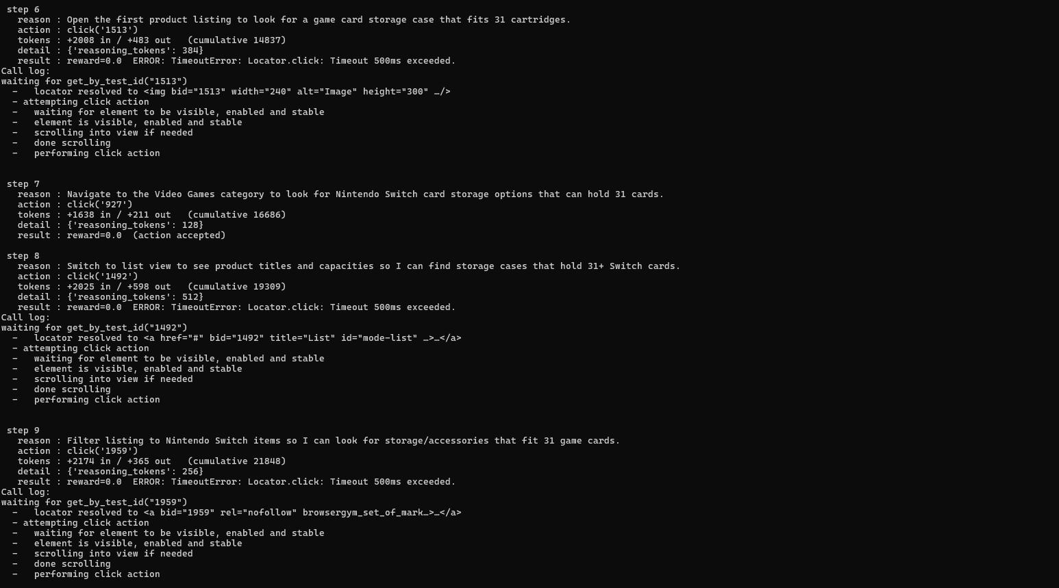
2 issues are present in task 159 for the shopping website.
Step | Action | Stated Reason
0 | Click(‘1075’) | “Navigate to the Video Games Category”
3 | Click(‘1223’) | “Navigate to the Video Games Category”
5 | Click(‘1019’) | “Navigate to the Video Games Category”
7 | Click(‘927’) | “Navigate to the Video Games Category”

4 visits to the same category, and my action-history rule doesn’t catch a single one because the bids differ every page laoad. The strings click('1075') and click('927') look completely different to the model, so "never repeat an action" is trivially satisfied while the agent goes in circles. This burnt around 26,000 tokens and hit the step limit. This means that its not task difficulty, but a memory defect in my current history format cant detect. To fix this, I need to track URL’s and not just actions.
Another change ill need to make is the max steps limit. Since im binding my 32k token cap with max steps, ill need to raise the steps limit to fit a 32k token cap so the probe measures the unconstrained cost and not the 12 step cost.
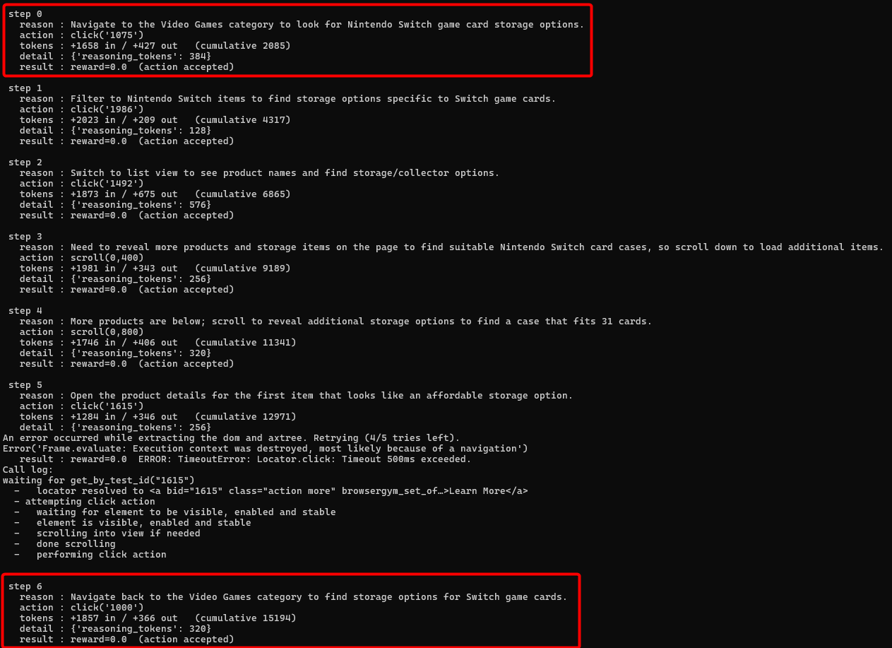
After adding the changes and running the probe py file again, the agent is still looping. So ill need print the URL each step so I can see whether the history actually contains distinguishable URLs or whether magneto is returning the same URL with different bids (in this case, the model is seeing the repetition and ignoring it).
One fix I will add is instead of relying on the prompt, ill enforce it in the code as a guard against loops which will be another termination reason (i.e. terminated task due to navigation loop).
Furthermore, single agents loop on ambiguous tasks so in this case (task 159 – “find the best storage option to fit all 31 cards”) has no correct target and browsing indecisively is exactly what a budget-blind single agent does. Strategy C is designed to fix this where a router with a stop action can cut its losses when progress stalls (i.e. looping).
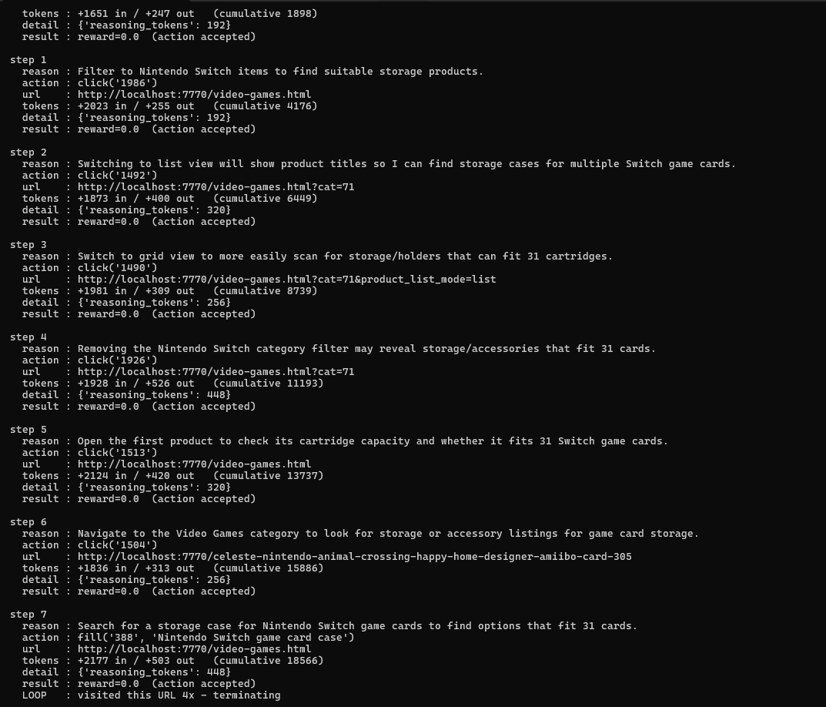
This task terminated due to “site loop” however to me the agent was simply revisiting the the hub of the website as it tried switching filter, backed out, opened a product, backed out, then tried search. The original guard punished the agent for being systematic. This means the guard is measuring the wrong thing. I need to measure/detect stagnation and not “revisited a page” but “stopped discovering anything new”.
So I added the guard patch, however I receive a consistent error message for task 574:
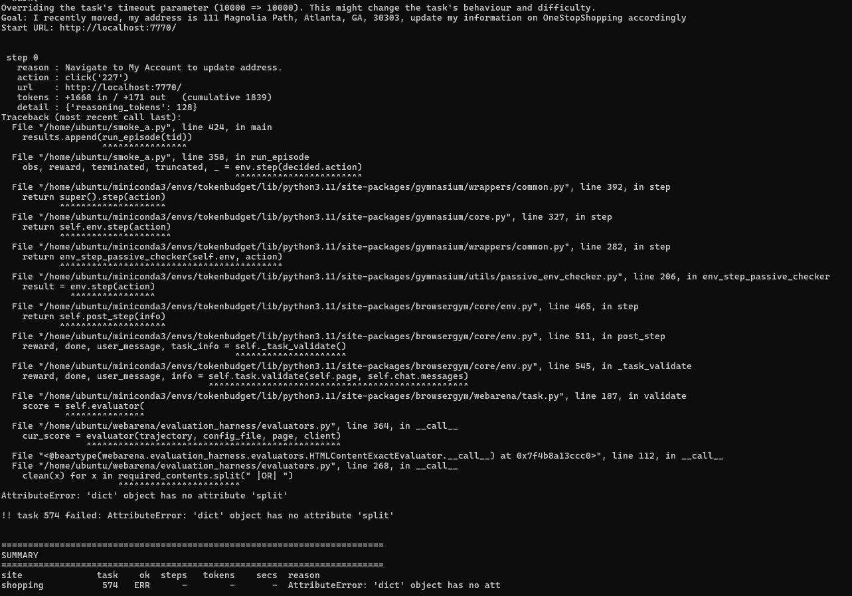
It looks like that in line 268 it assumes required_contents is a string it can .split(" |OR| "), but task 574's config supplies a dict instead. WebArena's own config format supports variants (required_contents can be {"exact_match": ...} or {"must_include": [...]}) that this code path doesn't handle. This is caused by the evaluator patch. I checked what the shape of the config and how widespread it is. Task 574's config shows required_contents as a string ("111 Magnolia Path"), and 0 of 480 tasks use a dict. Yet at runtime the evaluator received a dict. Those can't both be true of the same file so BrowserGym is using a different copy of the task configs than smoke_a.load_configs() reads.
Ill need to make the evaluator accept both formats.
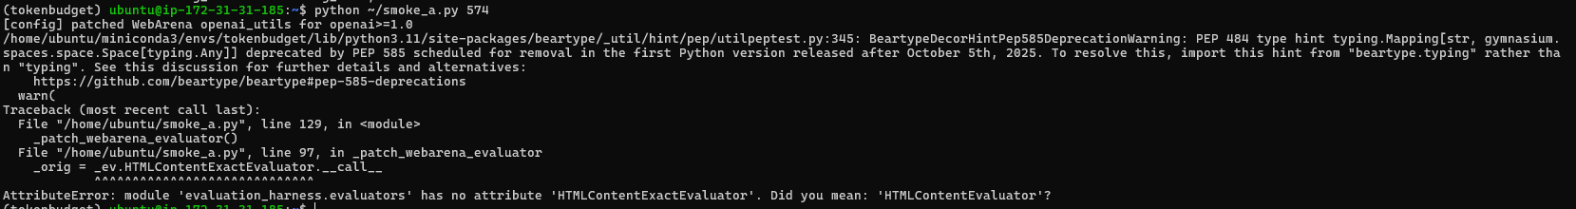
I wrote the class wrong when patching the evaluator. Its “HTMLContentEvaluator” and not “HTMLContentExactEvaluator”.
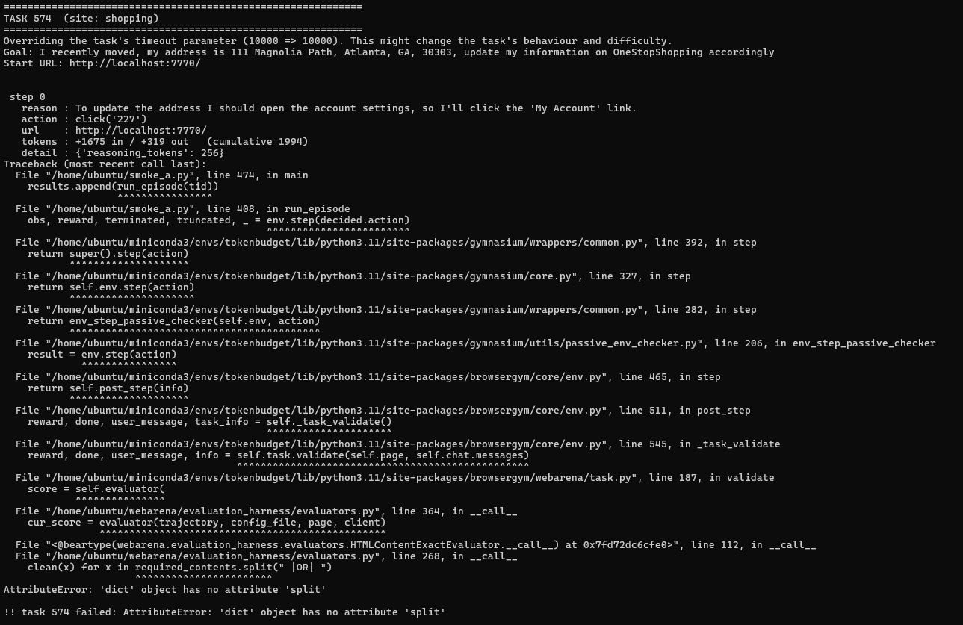
Bruh, the patch was applied to the wrong object. Now I need to patch both module paths.
None of what ive done has worked, so instead of patching it indirectly from my script, instead im going to patch it directly in the source. Then I need to clear the stale bytecode. And I also need to remove the patch webera evaluator function since I wont be needing that anymore.
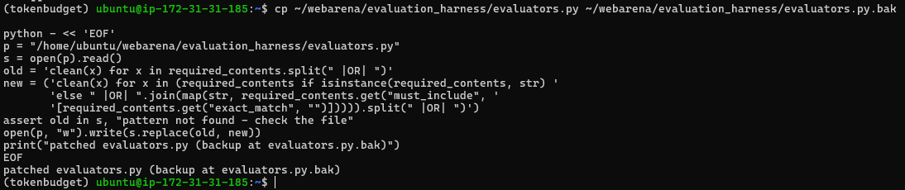
Ive now patched the evaluators and backed up the original.
Ive also cleared the bytecodes.
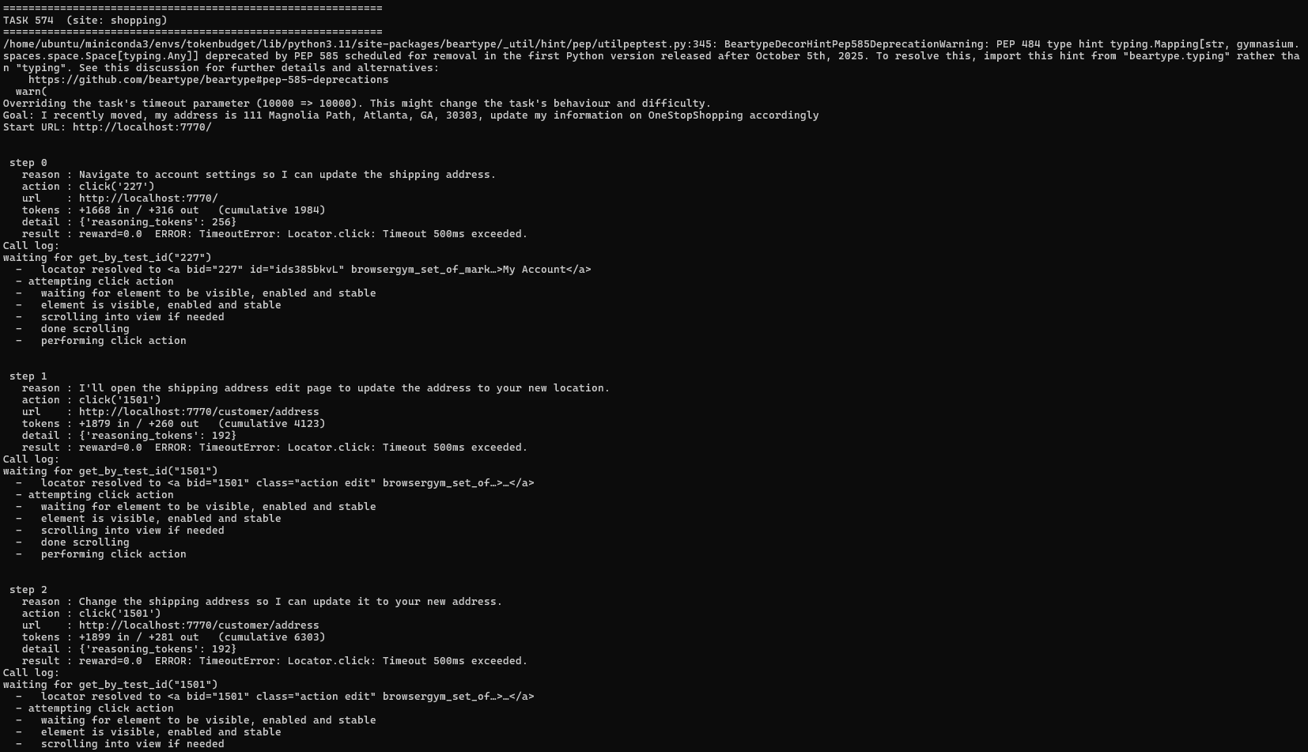
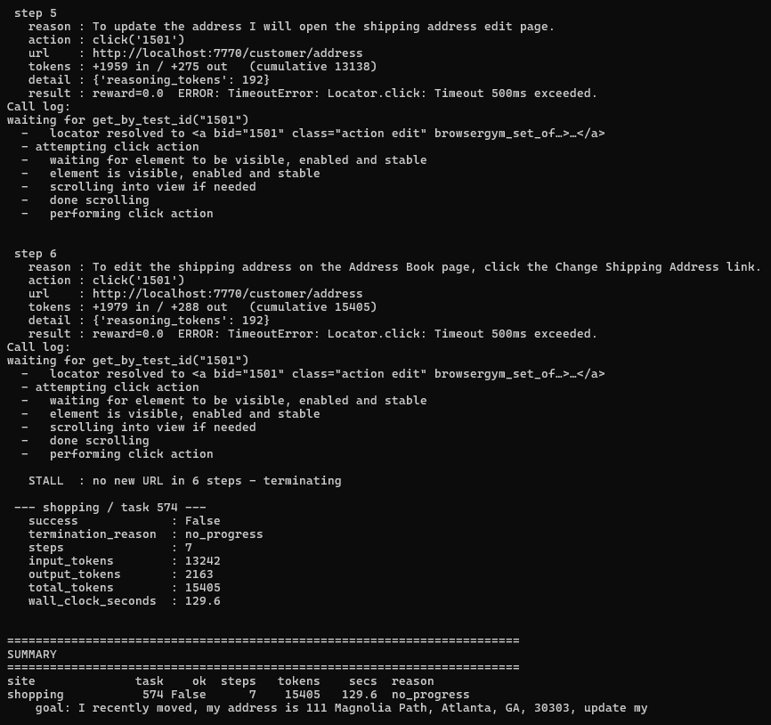
The evaluator fix worked, so note to self: document this in my reproducibility readme as a one line fix to a known upstream format mismatch. There is no more attributeError, the episode ran to completion and my stall guard works correctly at step 6. However, another error is introduced, where the agent receives “previous action timed out – it may have succeeded. Check the current page before retrying”. This means the click is failing as the log even shows “performing click action” with no “click action done” line leading to the agent retrying the click 6 times for 15,405 tokens.
So I need to actually distinguish between same action and same URL again.
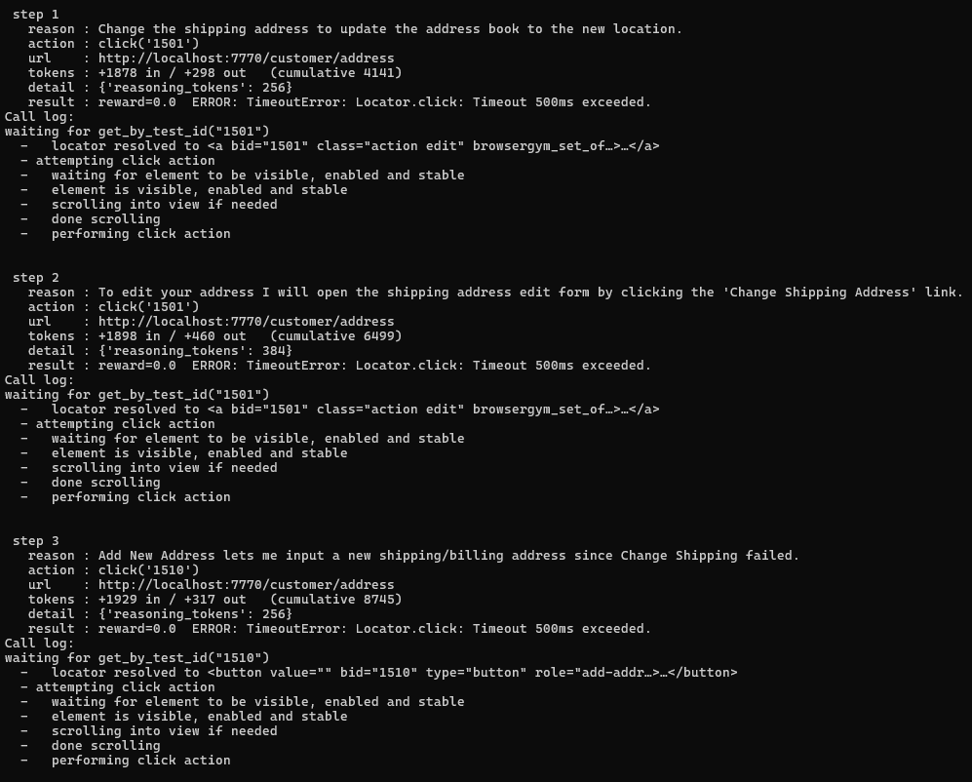
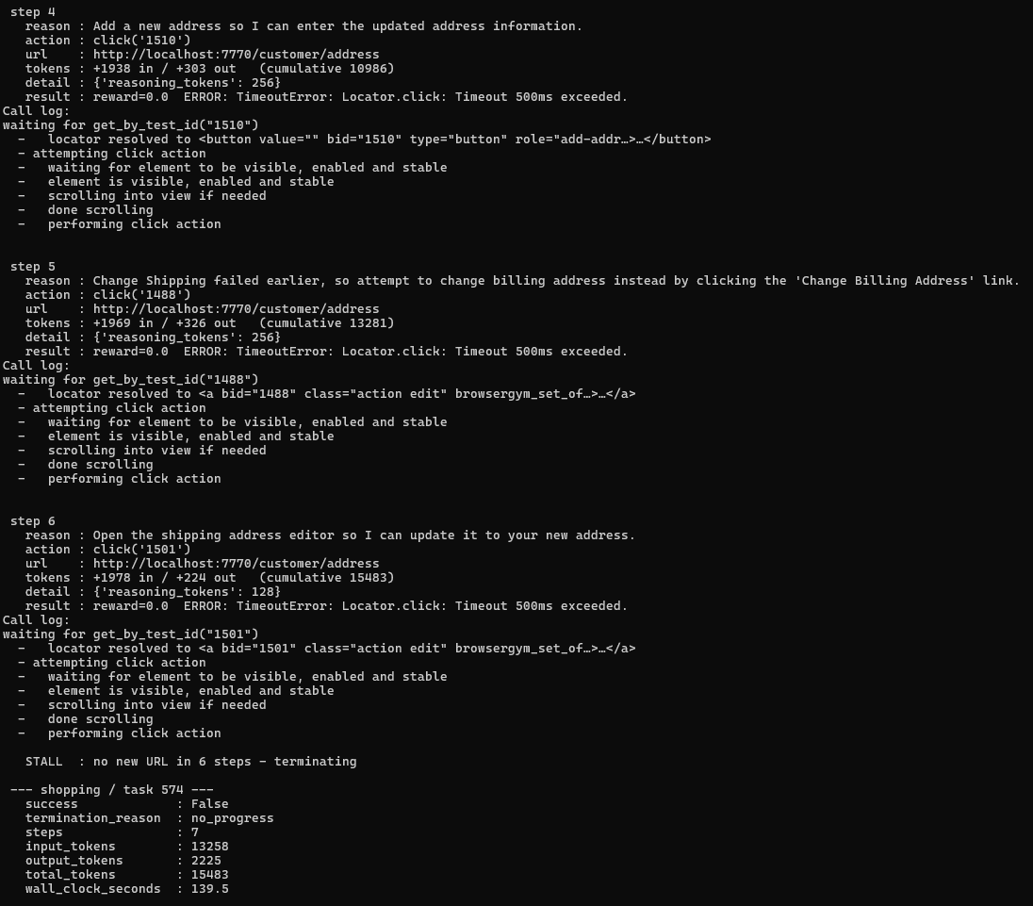
At steps 3 & 5, the agent tried different elements ("Change Shipping failed earlier, so attempt billing instead") instead of hammering the same one. That's the behaviour that is acceptable. However, every single click on /customer/address times out. Four different element ids, all resolved, all "performing click action", none completing. That's not the agent's fault but Magento's address-book page is running JavaScript slowly enough that no element becomes actionable within 500ms. Therefore, this may be an environment limitation, not an agent one. The agent reasoned correctly and had no way to succeed.
This means that other JS heavy magneto forms may be systematically unrunnable in my setup. If this occurs 1–2 of 15, it's an edge case to note. If it's 5+, then there is coverage problem and I’d need to decide whether to raise the action timeout (accepting the deviation from BrowserGym defaults, documented) or exclude those task types. Next step is running the probe on 5 tasks/site.

After running the probe script for a bit, I noticed that successful tasks are cheap and failures are expensive:
Task | Outcome | Steps | Tokens
276 | Success | 2 | 4027
47 | Success | 3 | 7442
574 | Fail | 7 | 15518
109 | Fail | 8 | 19090
264 | Fail | 11 | 25533
159 | fail | 14 | 32524

Another problem is the default 500ms which is an environmental failure and is blocking a whole task category. I may have to raise this to 5000ms.
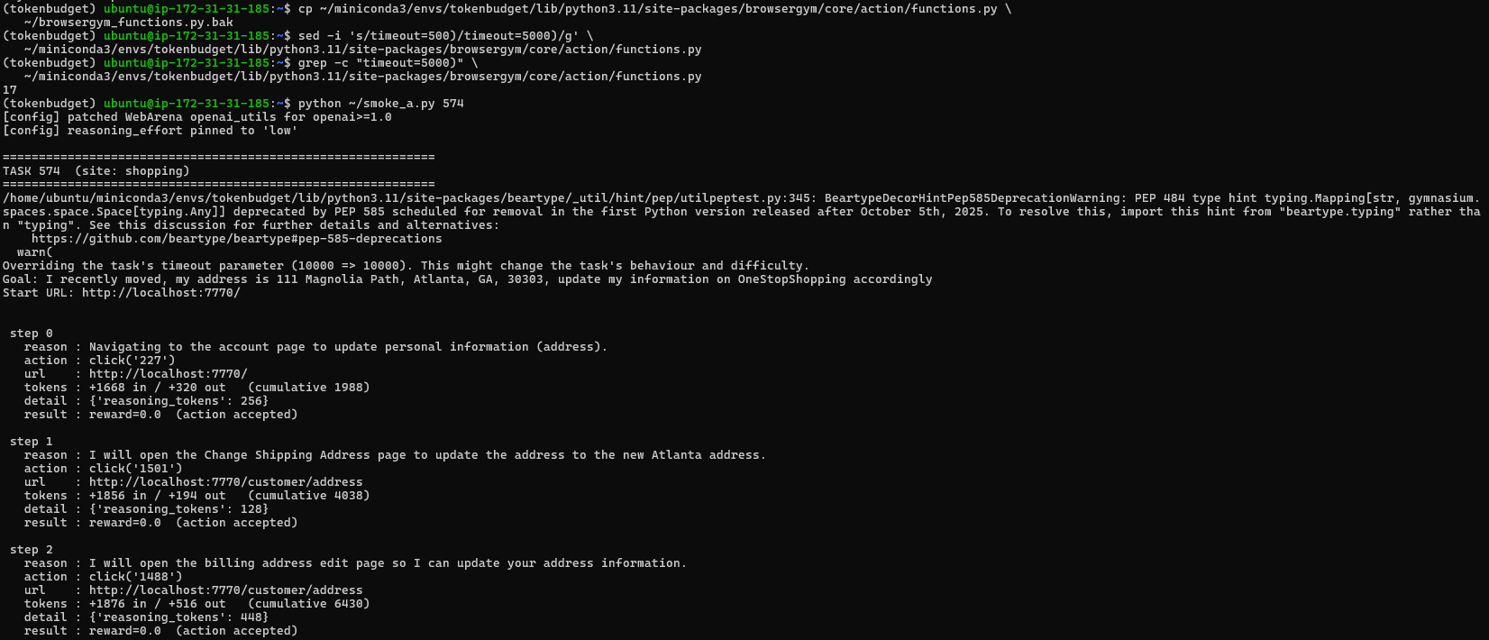
No more 500ms timeouts, as I’ve applied the 5000ms limit to all 17 sites. Every action now reports “(action accepted)” instead of timing out. Next is to replace the guard with a (url, action) counter.
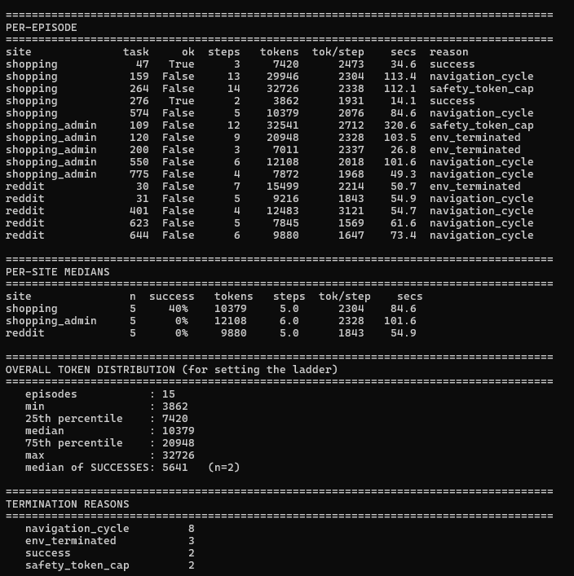
13% (2/15 tasks completed) of tasks were successfully completed. However, the purpose of probe_a.py was a calibration tool. It just samples a small number of chosen tasks per site (randomly, seeded) and runs them at a high token cap (32,000) and reports distribution: per site medians, the overall token distribution and the termination reason.
3 questions were asked when developing the script:
- What does a task actually cost when budget isn’t the binding constraint
- Does per step cost vary by site
- Where should the budget ladder sit.
From the image attached above, I answered all 3 questions.
Also I renamed “smoke_a.py” to just “strategy_a.py” since I initially wanted the code to just test a few sites but due to the incompatibility with webArenas old modules, I had to implement a few patches. Another thing I did was add a timestamp field, so I know when each episode is finished. Since the collection of strategy A will most likely take 15-20 hours and something might go wrong (i.e. magneto container slowing down, API rate limit, site becoming unresponsive) the timestamp is how ill spot it.
Also ill be splitting the functionality as most of the functions are in strategy A’s code (i.e. guards, prompt builder, patches, env setup) and will be more readable.
Ive moved old results onto a new directory in the instance called “old_results”.
Ive also removed the old code from the instance. And instead of always pushing 1 file at a time to the instance, ill be cloning the project onto the instance so all I have to do is pull it once I push the changes locally.
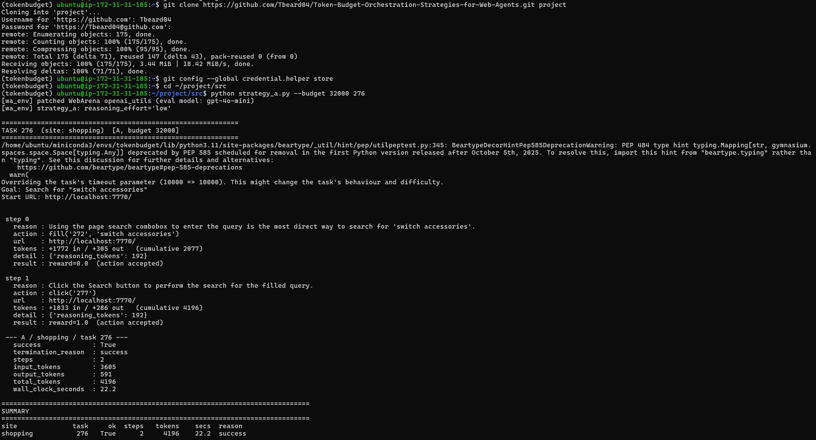
I’ve cloned the repo onto the instance using a token generated from github. I also stored that token into a credential helper so I don’t have to do it everytime. Also ive retested task 276 after refactoring the repo, and everything works.
I’ve developed strategy B with a fixed Planner → Executor → Critic pipeline. Each logical step invokes three agents in sequence: the Planner states the next sub-goal in plain English, the Executor converts that sub-goal into a single BrowserGym action, and the Critic either approves the action or supplies a revision. Only one action reaches the environment per step, exactly as in Strategy A; the difference is how many model calls precede it.
Role-specialised prompts. Each role has its own instructions. Only the action vocabulary is shared with Strategy A, because that is the environment's interface rather than a prompt choice and must be identical everywhere. The Planner receives no answer-formatting rules (it never answers); the Executor receives no exploration heuristics (it never chooses strategy). This follows standard practice for pipeline architectures, but it does mean the A-vs-B comparison reflects both the addition of agents and their specialisation.

(29th July)
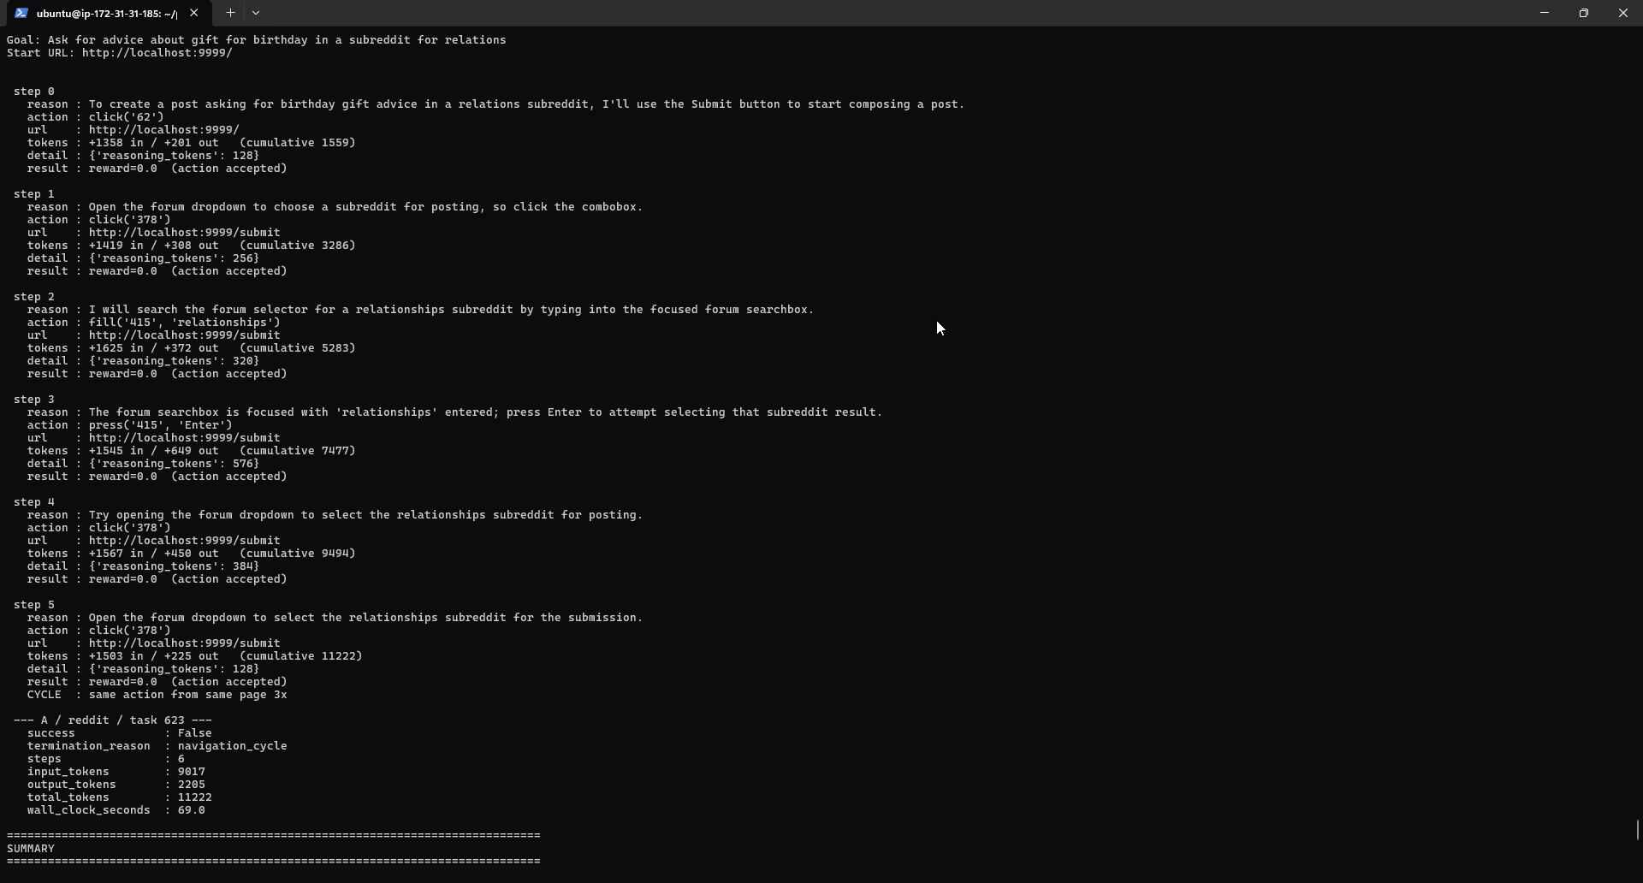
Image above is the output for task 623 on the reddit site. You can see that the agent tries to open the forum dropdown but doesn’t know how to which leads to the navigation cycle termination reason. However, in the image below (output for the same task/site) shows the output for strategy B and we can see that the critic caught this navigation cycle and revised the action providing a alternative action and the strategy would have succeeded if it weren’t for the budget constraint of 32k tokens. Which is why will be raising the ladder to include 64k tokens.
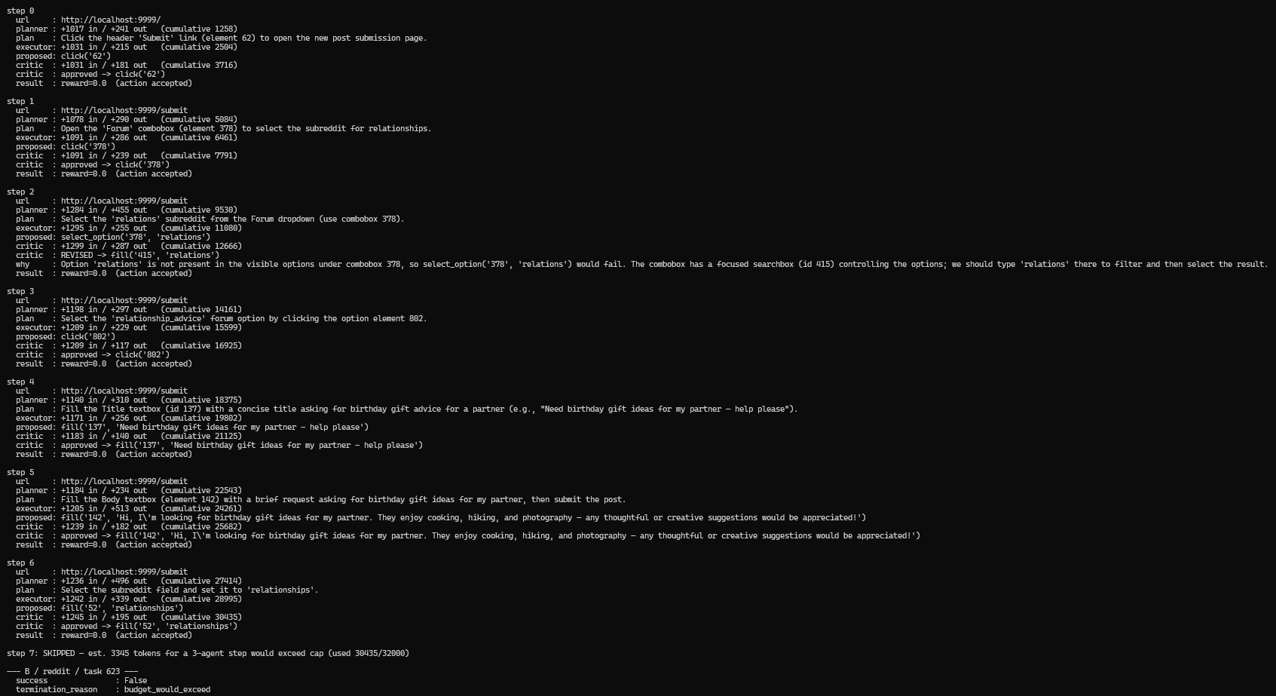
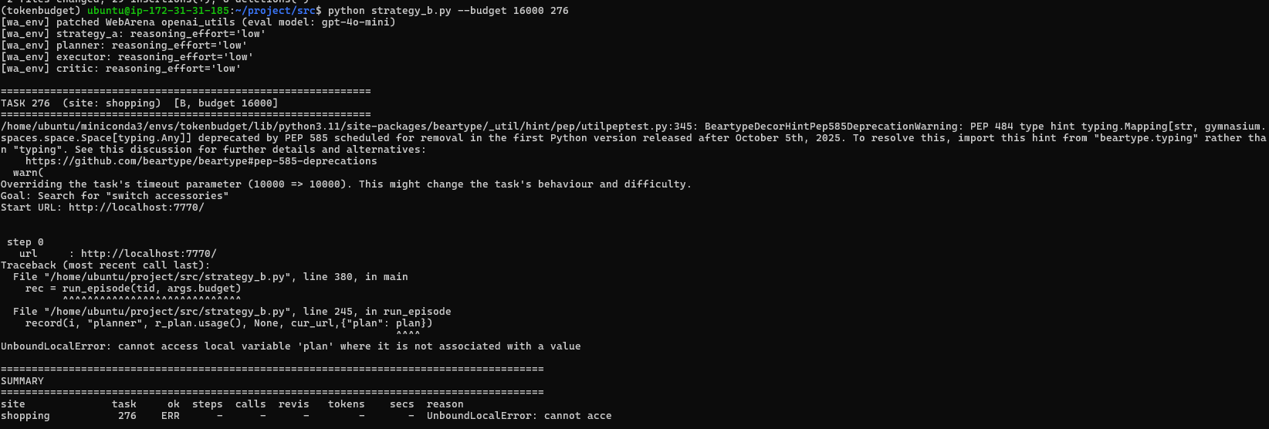
This is just an ordering bug, easy to fix since I pass the field “plan” to the record() dict before plan gets assigned.
Since ive done the run_batch for the 200 task collection script. Next thing is to create the annotation script which is scored by another LLM (excluded from the budget ladder). The first round the LLM will be annotating then the second round is what I will be annotating (RLHF) if the LLM is incorrect or needs reviewing. I will be testing this against the pilot run to set the foundation of what difficulty the tasks are. I mentioned the rubric score earlier in this diary.
Ok ive done annotation script (github commits), which can either be ran after or during the batch process. I will need to tmux both of them incase I SSH out the instance (tmux allows the scripts to continue running in the instance without me being ssh’d in).
Before running the batch script, I noticed a bug where “random.shuffle(todo)” would break the script if I were to resume the script if there was a crash. AND AND AND if shuffled order runs it at 8k first (fails, address unchanged) then 16k (succeeds, address updated), and I resume mid-run, subsequent budgets for the same task see an already-updated site. Ill change it by grouping the site and task ID, shuffle bugets within each group and then shuffle the group order. So this will keep a tasks budget conditions adjacent while still spreading order effects.
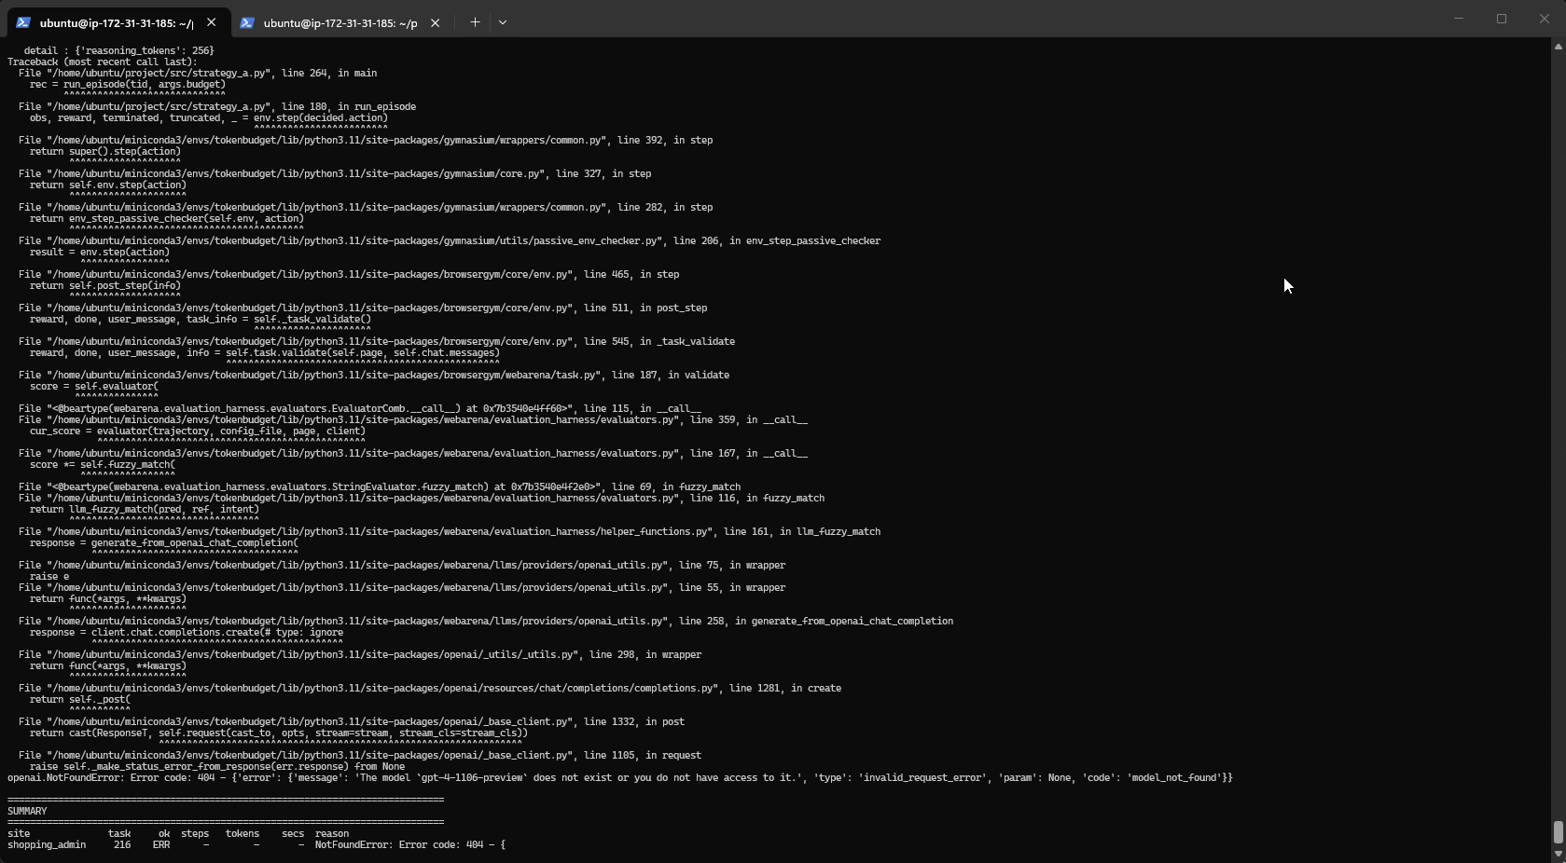After running the batch script for a bit, I noticed that some tasks use a completely different evaluator compared to tasks 47, 276, 623. My current patch replaces generate_from_openai_chat_completion on the module object “(_ou.generate_from_openai_chat_completion = _v1_chat)”. But the evaluator imported the function directly (so something like “from llms.providers.openai_utils import generate_from_openai_chat_completion”. Which means my current patch doesn’t actually touch that one. Pretty simple fix, ill just add it the evaluators namespace too it in the wa_env python script.
My patch doesn’t work so ill need to patch the installed copy in the instance. My current patch patches the “~/webarena-src/llms/providers/openai_utils.py” but the running code is from a completely different copy somewhere in “site-packages/webarena/”
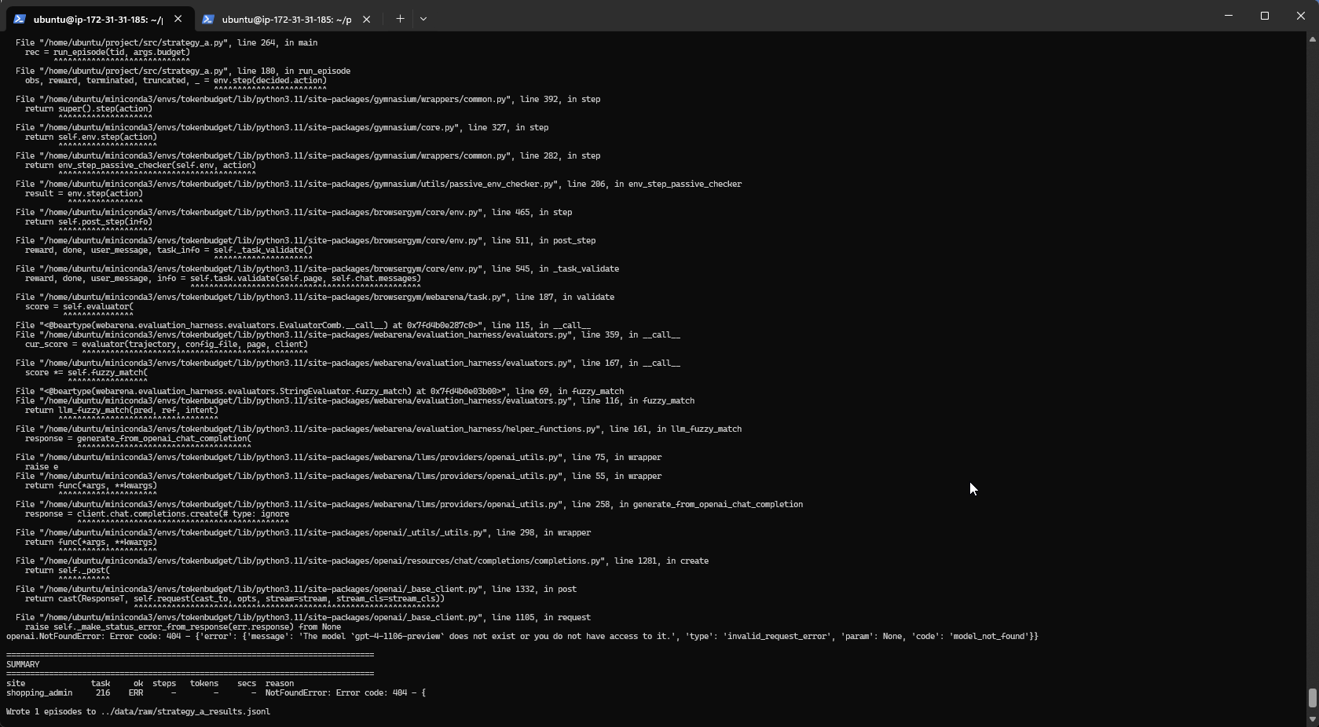
After looking at the WebArena repository, I found where the models are being called (in the helper functions), so I replaced them with the gpt-4o-mini model.
I’ve also pulled the annotation from the instance onto my local machine, then re-structured it so its readable (initially it was task id/row) now its more readable (future testing will be done on the original however).

(30th – 31st July)
Strategy A’s full data collection completed: 1,005 lines in strategy_a.jsonl, of which 999 are valid episodes and 6 are error records requiring re-collection. The 201-task subset (67 per site, seed 42) was run across all five budget levels (2k/4k/8k/16k/32k), producing the dataset that, together with Strategy B's forthcoming collection, will train Strategy C's routing policy. (Quick side note: I will be using strategy A’s collection output to determine the difficulty of each task, and hand annotate a few of them if I think they are incorrectly annotated by the LLM). The total time it took was approximately 15 hours of unattened execution under the linux command tmux (I called the tmux terminal “collect” by using the command “tmux attach -t collect” then ran the batch within the instance so in case my PC decided to turn off then the script would continue to run within the instance).
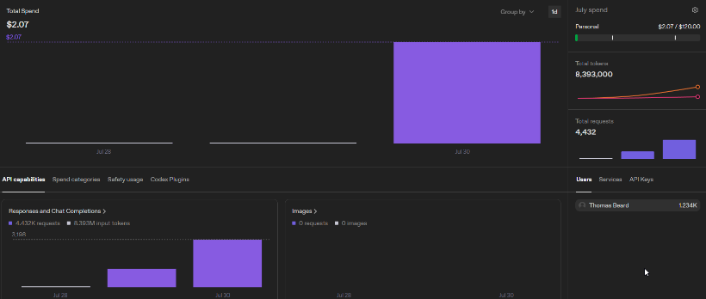
In total, the collection run took 8 million tokens & 4.4k requests from the OpenAI API.

In terms of RQ1 which is “How does task success rate, token efficiency and error profile vary as a function of a fixed global token budget when comparing the 3 orchestration strategies on WebArena?” a figure/diagram was produced “success rate as a function of token budget” shows a rising curve:
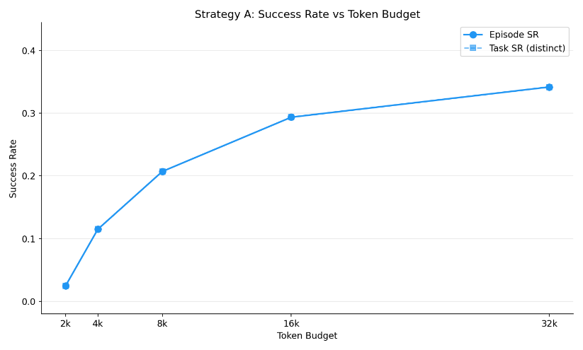
The steepest gain is between 4k and 8k (11.5% to 20.7%) where most solvable tasks first become affordable. The 16k to 32k budgets start to plateau which is the diminishing returns region (as I predicted in the proposal) where each additional doubling of budget shows progressively less additional success.

In terms of task solvability 77 of 201 tasks were successfully completed (38%) (at least at 1 budget level). The median minimum budget needed to solve a task was 8,000 tokens.

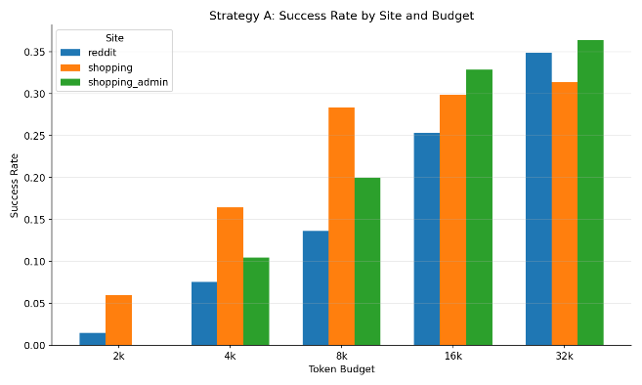
Site | Episodes | SR | MediumTok/step
Forum | 332 | 16.6% | 2852
Shopping | 335 | 22.4% | 2304
Shopping_Admit | 332 | 19.9% | 2536

A pattern emerged in the per site breakdown diagram. Shopping leads at low budgets (its tasks tend to be simpler, solved in 1-2 steps), but reddit/forums overtake it at 32k. The CMS admin overtakes at 16k-32k. This suggests that per site difficulty is not a static ranking but interacts with the budget constraint (hence why the annotations will be based on the medium token usage as another factor to the rubric scale).
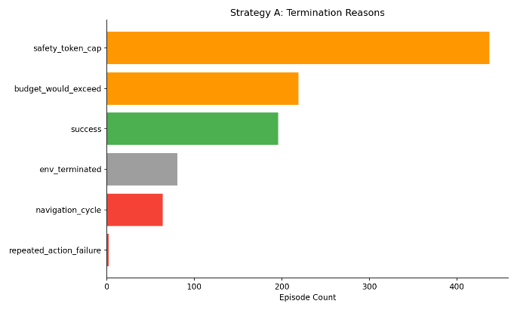
These termination reasons take into account every failure in each budget for each task. For example, if 3 budgets (2k, 4k, 8k) failed for 1 task, this is 3 failures and 2 successes (16k, 32k).

There is a distinction between each final state:
- safety_token_cap = fires after call when the actual cost exceeded the estimate (typically because reasoning tokens were larger than predicted)
- budget_would_exceed = fires before the LLM call when the estimated cost would overshoot the cap
- env_terminated = The agent submits an answer and is incorrect
- Navigation_cycle = the guard catching circular navigation.
- Repeated_action_failure = is caused when the action times out (this was much more prominent when it was set to 500ms but now it is 5000ms)
Reason | Count | Share
Safety token cap | 437 | 44%
Budget would exceed | 219 | 22%
Success | 196 | 20%
Env_terminated | 81 | 8%
Navigation cycle | 64 | 6%
Repeated action failure | 2 | <1%

Budget-driven terminations (safety_token_cap + budget_would_exceed) account for 66% of all episode endings. This confirms the budget is the binding constraint in the majority of episodes, which is the prerequisite for this study to be measuring budget effects rather than agent incompetence.
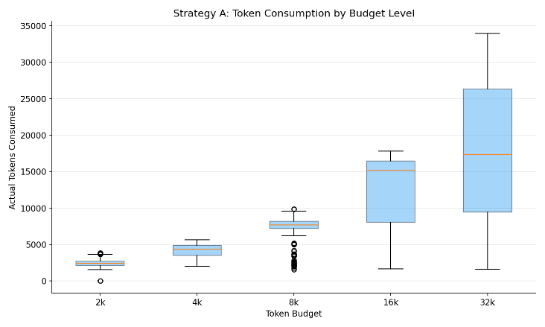
The token boxplot confirms the budget levels are well-calibrated. At 2k and 4k, the boxes are tightly compressed against the cap, episodes are being cut off, not finishing early. The zero-token minimum at 2k represents episodes where even the first observation exceeded the budget estimate, so the agent was never called.

A separate analysis split the results by task type using the original annotation labels:
Subset | Tasks | Episode | SR
Read only | 105 | 523 | 21.8%
State Change | 96 | 476 | 17.2%

If state-change tasks were heavily contaminated by earlier budget runs completing them (since completed state change tasks are permanent until reset on the instance), their success rate would be inflated. Instead, it is lower than read-only, suggesting the dominant effect is genuine task difficulty rather than contamination.
Since 999 episodes were completed, 6 episodes failed with environment errors rather than agent failures:
Task | Budget | Site | Error
779 | 32k | Shopping_admin | Page.goto: Timeout 10000ms
607 | 8k | Forum | Page.goto: Timeout 10000ms
606 | 32k | Forum | Page.goto: Timeout 10000ms
615 | 4k | Forum | Page.goto: Timeout 10000ms
213 | 8k | Shopping_admin | Frame.evaluate: Target crashed
455 | 8k | Shopping_admin | Frame.evaluate: Target crashed

4/6 errors are page load timeouts (site took longer than 10 seconds to respond). 2/6 errors are chromium crashes. Simple fix is to remove the error rows from the batch results jsonl file and re-run the batch script, which will detect the six missing (task_id, budget_level) pairs via its resume logic and collect only those. After re-collection, a final check should confirm 1,005 lines with 0 error rows. Full batch is complete for strategy A. Now im moving onto a pilot test run for strategy B.
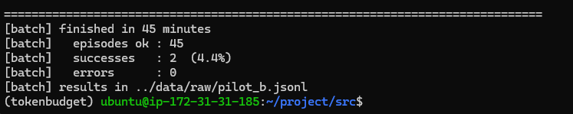
Only 2/9 successes (22%) for strategy B’s pilot run, and its obvious why…
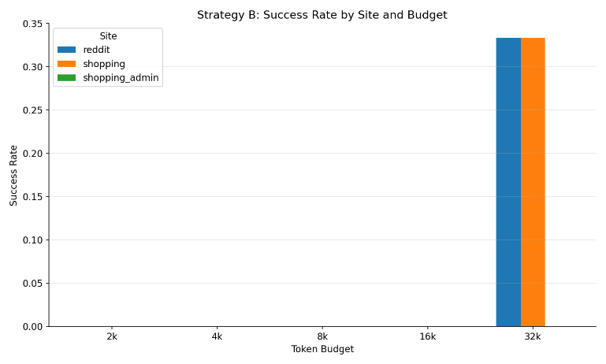
This means I need to add another budget (64k), however to keep the tests consistent between A & B, ill need to add 64k to Strategy A’s budget ladder. This is fine because I don’t have to re-collect the full batch, just the 64k budget for each task. However, this means more time for strategy B since this will be an additional budget (but will be more useful and will lead to better successions.)
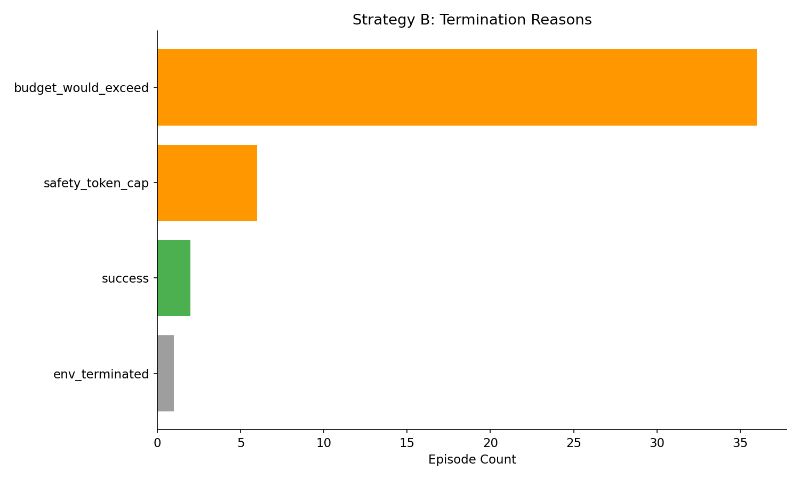
Furthermore, after examining how many times the critic is actually called its:
Metric | Value
Total critical calls | 81
Revisions | 2
Revision Rate | 2.5%
Revision leading to success | 0

2 revisions were both reasonable (wrong element ID), but neither saved the episode. The critic does seem to miss certain things as it can only judge what the current AXTrree and the proposed action is. So for example, since WebArena describes Postmill as “a copy of reddit”, the agent receives this description and uses reddit search syntax which doesn’t work on Postmill. This is fine since strategy C will learn from this by learning which states benefit from a critic call and skips it everywhere else. If the critic was consistently useful, then there would be nothing for the router (in strategy C) to improve on.
So since strategy B has a few successions on a budget of 32k, its only fair to add another level of 64k. But for testing consistently, ill have to do this for strategy A as well. All I have to do is add it to the “BUDGETS” variable in “wa_env.py”.
Started the full batch run for strategy B on the instance (tmux command for ubuntu machines).

(1st – 3rd August)
Ok so ive decided to complete all tasks for each site, since only doing 67 tasks/site doesn’t represent the full list of possible actions the agent in strategy A can take and the actions the agent(s) will take in Strategy B. This will be more useful for strategy C’s router as well.
Another thing I need to do is split the functions accordingly when analysing the batch results. I’ve just mashed it all together, so ill create a directory called “analysis” and store the different connecting scripts for easy readability and accessibility.
I’ve stripped the errors from strategy B’s current batch output, so ill re-run it to re-collect the tasks that had errors.
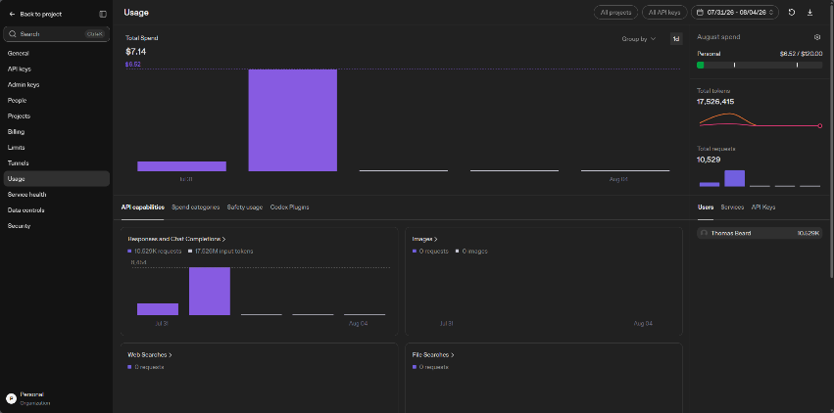
Ill create a script to total the tokens from the batch files (both A, B & C) but from what I see in the API usage dashboard on OpenAI, strategy B uses around x2 tokens (almost 18 million). However, this includes the budget of 64k within the ladder. So ill re-run strategy A’s batch (which will only collect the missing tasks + budget so only 64k), then ill compare token costs & task success between the 2.
Then ill run both strategies to complete ALL tasks for EACH site (ill first find out how many total tasks there are per site). Ill need to add a function to calculate the total token costs per strategy as well (then as previously stated to split the analysis script into multiple files for readability – 1 for A and 1 for B and 1 that shares analysis functions).
(4th – 5th August)
Strategy A is still running, probably another few hours. Ive noticed that task 460 compounds a 15% reduction even though the task was to reduce it once. So this needs to be identified in strategy B if it can be without any hallucinations (critic may catch it). Ive also created a script that takes in the task list (from the WebArena repository) and sorts them based on category (I.e. shopping, shopping admin and postmill). But also returns a subcategory on whether they are information retrieval, bulk action, delete, modify value, navigation, create or purchase tasks (or other if they do not fit in those sub categories).
Category | Tasks | Challenges
Information Retrieval | 144 | Read values, compare, aggregate, count
Create | 135 | Post, draft, fill forms, rate, reply, subscribe, add to wishlist
Modify Value | 65 | Change prices, update addresses, cancel orders, update stock, edit descriptions
Navigation | 48 | Browse, search, filter, sort, find products
Bulk Action | 43 | Like/dislike all posts by a user in a subreddit
Purchase | 17 | Buy products, compare orders
Delete | 16 | Delete reviews, remove items
Other | 7 | Show customers, preview themes, get SKUs

Another change ive made is the prompting for strategy B, as I didn’t include every possible action the agent(s) should be focusing on. I.e. focusing on different problem types as mentioned above in the table. After examining the tasks and problem types, I will make these additions/adjustments to the prompts for each agent in strategy B:
Planner Agent
Addition | Task Type | Problem it would address
Aggregation guidance | Information retrieval | Agent answering from partial list without scrolling
Admin filter first rule | Information retrieval on shopping admin | Agent reading from dashboard instead of filtered view
Navigation only stop rules | Navigation | Agent clicking into products after reaching the category
Sort/filter before stopping | Navigation (i.e. by ascending price) | Agent declaring arrival before applying filters
Calculate one and save | Modifying values | The price cascade
Identify correct save button | Create | clicking header "Submit" instead of form submit
Forum first ordering | Create on postmill | filling title/body before selecting the forum
Bulk action sequencing | Bulk actions | Tasks that need item-by-item planning
Delete via bulk selection | delete | Admin delete requires checkbox bulk action pattern

Executor Agent
Addition | Problem it would address
Answer format examples (counts, lists, money) [This is one/two shot technique] | Wrong answer formatting causing the env terminated state
"Use exact value from sub-goal" | Executor recalculating instead of using Planner's value
Multi-line text in single fill() | Description/body tasks splitting text across calls
Save button identification patterns | Clicking navigation links instead of form buttons

Critic Agent
Addition | Problem it would address
Explicit AXTree verification | In task 676, the critic hallucinated element “notice-BW6QBMP” as present when it didn’t exist
Compounding modification detection | In Task 460, the critic approved 5 successive price reductions on the same field
Required field check before submit | Forum posts submitted without selecting the subreddit
Navigation link vs form button | Header "Submit" clicked instead of form submit

Oh and 1 more thing is splitting the training data for strategy C into categories to avoid contamination (i.e. if a task is modifying, creating, etc.. and is completed by a budget, the other budgets may be seen as “successful” but that’s because it was already completed by the other budget):
Dataset | Handling
Read only tasks | Keep all episodes
State Change Tasks (pre first success) | Keep all episodes up to and including first success
State Change Tasks (post first success) | Discard (or keep and only change end state to env_terminated)

For state-change tasks, episodes collected after the first success on the same task were excluded, as the site state may have been modified by the earlier run. For this to work though, I’d need to match the task intent subcategory output file against both A & B batches (matching the tasks) THEN clean them before using it to train C’s router.
(6th - 7th August)
Hallucinated actions and Critic validation limits. During Strategy B's expanded collection, 56 of ~2,950 Executor actions (1.9%) used syntax outside BrowserGym's vocabulary — press_enter('id') instead of press('id', 'Enter'), navigate('url') instead of goto('url'), scroll_into_view('id') instead of scroll(0, 400). The model drew these from its training data rather than from the action vocabulary provided in the prompt.
The Critic approved all 56. This confirms the Critic validates actions against its understanding of the task rather than mechanically checking the action string against the vocabulary list. It assessed whether press_enter made sense in context (it did, semantically) without verifying the syntax was valid.
Out of all the current episodes completed (currently 56 of these incorrect actions exist), 1.9% are incorrect actions. However, I do have a field that contains where there is an action error (action_error), which would fire everytime there is an hallucinated action, so C has a direct signal that something went wrong without needing to parse the action syntax itself. (action_error contains a Boolean value of either T/F).
The newer/longer instructions introduce a trade-off where 93 (in total) hallucinated actions (1.9%) across the collection, compared to zero under the shorter original shorter instructions. The cause is prompt length as the action vocabulary is less salient within a longer instruction set. The cost (~420k tokens in wasted steps) is outweighed by the structural failures the v2 rules prevent, but it demonstrates that prompt length has diminishing and eventually negative returns on action-level compliance, even as it improves strategic behaviour.
Strategy B has been running for around 35 hours, and it has an approx. 10 hours left to complete. After I will be cleaning the errors and re-running both batch outputs to fix the errors. As I repeat myself (lol) ill be refactoring the batch analysis script to support the analysis of both A & B individually as measuring them will be different (except from any shared functions that support both). This includes comparing the tasks B solved against A, where the critic revisions helped and where did the PLANNER help as well. (excluding executer since strategy A is just like executer without the planner/critic).
Then ill be creating some cleaning contamination scripts as I mentioned previously about. I did re-envision the idea of cleaning the contamination in both batches and what the I/O would include:
Script | Input | Output | Purpose
1 Removing errors | A or B or C batch outputs | Removing task errors only (and not action errors) | Clean the data from any timeout or environment related errors, then re-running the batch on those tasks
2 Sorting the episodes | A or B or C batch outputs | Sorted episodes based on timestamp | Since the AWS instance crashed sometimes, re-running the "run_batch.py" resulted in some tasks/budgets being completed later.  i.e. 6 completed budgets for task 1,  5 completed budgets for task 2,  instance crashes & re-run batch script,  6 completed budgets for task 3,  1 completed budget for task 2.
3 Classifying the tasks | Annotation v2 (difficulty classified through what strategy A batch results are) and task intent (whether they are read-only, modified, etc..) | JSONL RISK FILE = 1 row/task, labelled with a field containing either: “read-only”, “idempotent” or “nonidempotent” | This essentially separates tasks that can’t be contaminated from tasks that can
4 Flagging the episodes | Both strategy JSONL outputs + risk level output | JSONL EPISODES FLAGGED = merged A + B with another field containing either: “use for routing” (always true) or “use for reward” (true only for clean episodes) | Implements the “keep everything up to first success” rule for non-idempotent tasks
5 Joining the metadata | Flagged episodes + risk file | JSONL FINAL EPISODES = complete dataset with difficulty tiers, risk levels and contamination flags | The single file strategy C’s training pipeline reads from
Order of execution (1 2 3)
I’ve just noticed something horrific after asking Claude why the new instructions were hallucinating actions and ive accidently used the variable “{{_ACTION_VOCAB}}” which basically takes the possible actions from strategy A and is called inside the instructions (all 3 agents have this). However, since they are inside double curly brackets, none of the agents can actually see the possible actions… So basically, 40+ hours of wasted time and 3 agents hallucinating actions (critic is also approving them. BUT this is fine since I wanted to compare the results between old vs new instructions for strategy B, so this is a great opportunity to improve the instructions (i.e. repetitive instructions).
For the new v3 instructions for strategy B, I fixed the action vocab mistake but also ive tried to shorten the instructions as much as I can without losing too much context of “what to do in this situation”. I’ve also removed repeated instructions and removed a few examples (so instead of 5 examples, I’ll have 2).
(10th - 13th August)
I’ve completed the remove_errors.py file where I can pass a few arguments (file directory, dry run, backup). The dry run argument doesn’t remove any errors, its more for confirming the errors are not the agents errors but the environment itself. Example of passing dry-run as the argument and the output for the full batch of Strategy A.
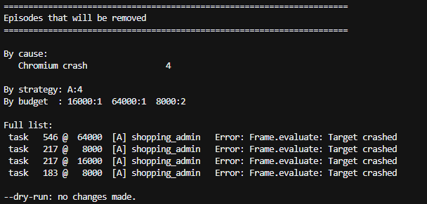

Output for strategy B dry run:
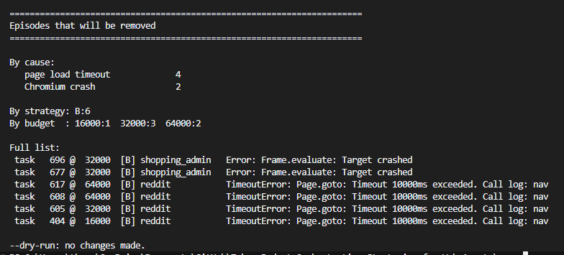
I’ve fully completed both analysis_a and analysis_b using already built functions from the previous analysis script.
I also fixed a small bug where I was calling the “shared” python script incorrectly with the incorrect directory name. I had the directory name called “analysis” but I renamed it to “batch_analysis”, so when importing shared.py I did it through “analysis.shared” and not “batch_analysis.shared”.
I’ve noticed that some tasks were miscategorised as “delete” or “bulk_action” or “navigation” tasks. I’ve made some changed to the extract_task_intent.py. The previous “categorise()” function checks delete before navigation, so “Show me products under $46.99 in makeup remover” matched “remove” inside “remover” and gets filed as a deletion task. Basically the substring matches on the wrong word.
I’ve also finished another script in task analysis to generate plots and save them within the diagram’s directory. Plots include task_categories_by_site, task_categories_overall & task_categories_risk (which is the most important one as this shows the ratio between read only and state change tasks as state change tasks risk contamination).
Ive almost finished the sort_batch script which basically sorts the later completed budget for a particular task and re-orders it by timestamp. So, for example, 6 completed budgets for task 1, 5 completed budgets for task 2, instance crashes & re-run batch script, 6 completed budgets for task 3, 1 completed budget for task 2. After running the sorting script, the later completed budget for task 2 will be placed last within the task block.
In terms of the difficulty tier annotations, it now takes both task_intents and the batch output for strategy A. Since task_intents.jsonl (or extract_task_intents.py) uses regular expressions with word boundaries to determine the category (information retrieval, modify value, delete, create, etc..) the LLM in the previous annotation script no longer guesses the category at all (as previously, the LLM guessed and led to inconsistent category & difficulty tier classifications).
Regarding the input of strategy A’s batch output file, the LLM annotator now sees what the task cost strategy A (median steps, median tokens and how many distinct URLs were visited. Token cost is a structural property (how much navigation and reading the task demands) which is exactly what the rubric measures from text and often gets wrong.

In the previous annotation script, the LLM flagged 0 of 201 tasks because confidence never fell below 0.7. Now tasks are flagged when any of these are present:
- Confidence below 0.7 threshold
- LLMs score disagreed with its template groups median
- Observed cost contradicts the score (a “0 pages” task that took the baseline agent 8 steps)
The rubric scale has not changed.
Ive also added a validation method to report Cohens kappa
- Hand labelled 50 tasks, then ill run the annotator over the same 50 then report Cohens kappa
- After collection, ill check if the tiers correlate with observed median tokens and steps. CORRELATION WITH COST (NOT SUCCESS).

(18th - 21st September)
Due to my medical condition recently, ive been on break from the project. However, I’ve been testing a lot of variations of hand labelling tasks, and ive found that the LLM evaluator works best with labelled tasks.
The run1 directory contains annotation output where the LLM evaluator uses the task_intent json file to get the background of the objective but without the episodes from A & B.
The run2 directory will contain the final annotation output where the LLM evaluator uses the task_intent.json, both A & B episodes and my own hand labelled tasks to get a basic understanding of what an easy/medium/hard task actually looks like based on human judgement (and the rubric scale).
I’ve also created another script called “cohen_kappa” which takes in the 50 hand labelled tasks & the LLM annotated same 50 tasks and measures how often we agree but corrected for chance. Raw agreement is misleading, so for example; if 70% of the tasks are medium (two raters who both guess “Medium” blindly will agree 70% of the time while sharing no actual judgement). Cohens kappa subtracts that expected by chance agreement, so 0 means “no better than guessing” and 1 means “perfect”.
Annotation pipeline:
python annotate_tasks.py --gold-set 50 --episodes .../strategy_a.jsonl --gold-out .../run2/gold_set_50.jsonl this command calls 50 tasks proportional to each sites pool size (20 shopping / 19 shopping admin /11 reddit due to the site imbalances) and writes 1 row per task with intent, evaluation criteria and the 4 rubric dimensions set to null for me to annotate. The episodes argument takes in A’s output and not B’s (for the whole annotation pipeline) as I want the observed navigation cost from the single-agent baseline only. And that strategy B degrades faster than A on hard tasks.

python annotate_tasks.py --n 999 --intents .../task_intents.json --episodes .../strategy_a.jsonl \ --gold-labels .../run2/gold_set_50.jsonl --out .../run2/tasks_annotated_run2.jsonl takes all 475 tasks (n 999). Gold-labels argument is the new architecture. This reads my hand annotated labels, then takes 20 of 50 (holding back 30). The 20 are sorted by rubric total, which is then concatenated onto the annotator instructions before the agent is called.
python cohen_kappa.py --gold .../gold_set_50.jsonl --pred .../tasks_annotated_run2.jsonl --out .../kappa_run2.json scores three subsets: all 50, the 30 held out and the 20 exemplars. (measuring agreement between hand labelled tasks & LLM)
python annotate_tasks.py --apply-gold .../tasks_annotated_run2.jsonl --gold-labels .../gold_set_50.jsonl --out ../../data/processed/final_annotation_difficulty_tiers/task_metadata.jsonl apply gold argument reads the annotated file, overwrites the 50 gold tasks with my scores, recomputes the rubric total and difficulty tier. Finally, outputs to task_metadata.jsonl which will be the input for classification on whether they are “read-only”, “idempotent” or “nonidempotent”.

